Task 2: Test log
Description of test | Test data to be used (if required) | Expected outcome | Actual outcome | Comments and intended actions
Testing the logo in navigation bar | No test data | Upon clicking, home page is loaded | Expected outcome was met and clicking the logo caused the Home page to load | PASS
Testing the Shop navigation button in navigation bar | No test data | Upon clicking, Products page is loaded | Expected outcome was met and clicking the Shop button caused the Products page to load | PASS
Testing the Growers navigation button in navigation bar | No test data | Upon Clicking, Producers page is loaded | Expected outcome was met and clicking the Growers button caused the Producers page to load | PASS
Testing the Orders navigation button in navigation bar as a logged in user | No test data | Upon clicking, Orders page is loaded | Expected outcome was met and clicking the Orders button caused the Orders page to load | PASS
Testing the Orders navigation button in navigation bar as a non logged in user | No test data | Upon clicking, Access Denied page is loaded | Expected outcome was met and clicking the Orders button caused the Access Denied page to load | PASS  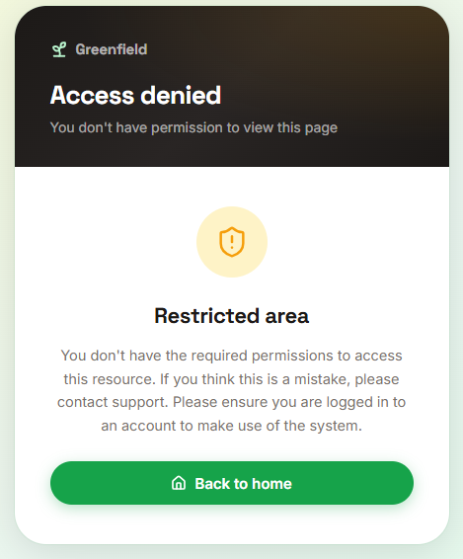
Testing the Register navigation button in navigation bar | No test data | Upon clicking, Register page is loaded | Expected outcome was met and clicking the Register button caused the Register page to load | PASS
Testing the Login navigation button in navigation bar | No test data | Upon clicking, Login page is loaded | Expected outcome was met and clicking the Login button caused the Login page to load | PASS
Testing the Basket navigation button in navigation bar as a logged in user | No test data | Upon clicking, Basket page is loaded | Expected outcome was met and clicking the Basket button caused the Baskets page to load | PASS
Testing the Basket navigation button in navigation bar as a producer | No test data | Upon clicking, Access Denied page is loaded | Expected outcome was met and clicking the Basket button caused the Access Denied page to load | PASS  
Testing the All Products navigation link in page footer | No test data | Upon clicking, Products page is loaded | Expected outcome was met and clicking the Products link caused the Products page to load | PASS  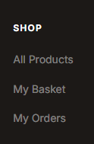
Testing the My Basket navigation link in page footer as logged in user | No test data | Upon clicking, Basket page is loaded | Expected outcome was met and clicking the Basket link caused the Basket page to load | PASS  
Testing the My Basket navigation link in page footer as non logged in user | No test data | Upon clicking, Access Denied page is loaded | Expected outcome was met and clicking the Basket button caused the Access Denied page to load | PASS  
Testing the My Basket navigation link in page footer as producer | No test data | Upon clicking, Access Denied page is loaded | Expected outcome was met and clicking the My Basket link caused the Access Denied page to load | PASS  
Testing the My Orders navigation link in page footer as logged in user | No test data | Upon clicking, Orders page is loaded | Expected outcome was met and clicking the My Orders link caused the Orders page to load | PASS  
Testing the My Orders navigation link in page footer as non logged in user | No test data | Upon clicking, Access Denied page is loaded | Expected outcome was met and clicking the My Orders link caused the Access Denied page to load | PASS  
Testing the My Orders navigation link in page footer as producer | No test data | Upon clicking, Access Denied page is loaded | Expected outcome was met and clicking the My Orders link caused the Access Denied page to load | PASS  
Testing the Meet the Farmers navigation link in page footer | No test data | Upon clicking, Producers page is loaded | Expected outcome was met and clicking the Meet the Farmers link caused the Producers page to load | PASS  
Testing the Producer Dashboard navigation link in the page footer is hidden for standard logged in users | No test data | The navigation link for Producer Dashboard is hidden | Expected outcome was not met and the navigation link for Producer Dashboard is visible. | FAIL  FIX  REGRESSION TEST – PASS  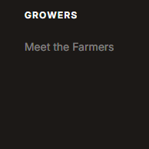
Testing the Producer Dashboard navigation link in the page footer is hidden for admins | No test data | The navigation link for Producer Dashboard is hidden | Expected outcome is met and the navigation link for Producer Dashboard is hidden | PASS  
Testing the Producer Dashboard navigation link in the page footer is visible for producers | No test data | The navigation link for Producer Dashboard is displayed in the page footer visibly | Expected outcome was met and the navigation link for Producer Dashboard is visible. | PASS  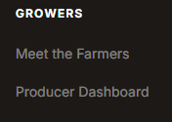
Testing the Producer Dashboard navigation link in the page footer is visible for developers | No test data | The navigation link for Producer Dashboard is displayed in the page footer visibly | Expected outcome was not met and the navigation link for Producer Dashboard is hidden. | FAIL  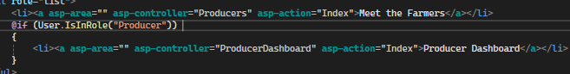  FIX  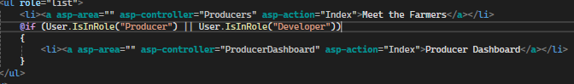  REGRESSION TEST – PASS  
Testing the Producer Dashboard page is not accessible by standard users | No test data | Attempting to access the Producer Dashboard loads the Access Denied page | Expected outcome was met and clicking accessing the page through the web address loaded the Access Denied page | PASS  
Testing the Producer Dashboard page is not accessible by admin users | No test data | Attempting to access the Producer Dashboard loads the Access Denied page | Expected outcome was met and clicking accessing the page through the web address loaded the Access Denied page | PASS  
Testing the Producer Dashboard navigation link in the page footer takes you to the correct page | Must be logged in as developer or producer role assigned account | Upon clicking, Producer Dashboard is loaded | Expected outcome was met and clicking the My Orders link caused the Access Denied page to load | PASS  
Testing the Privacy navigation link in page footer as producer | No test data | Upon clicking, Producer Dashboard is loaded | Expected outcome was met and clicking the Privacy link caused the Privacy page to load | PASS  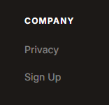
Testing the Sign-Up navigation link in page footer as producer | No test data | Upon clicking, Register page is loaded | Expected outcome was met and clicking the Register link caused the Register page to load | PASS  
Testing the Account Profile navigation button in navigation bar as logged in user | No test data | Upon Clicking, Account Settings page is loaded | Expected outcome was met and clicking the Account ‘hello email’ caused the Account page to load | PASS  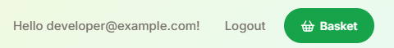  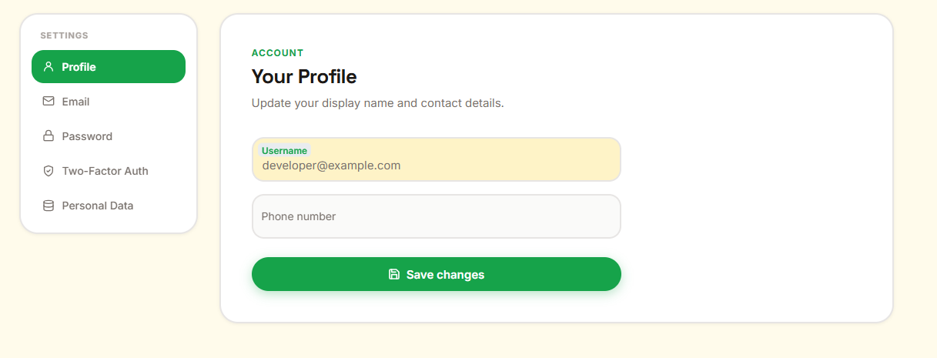
Testing Account Profile page as a non logged in user through web address | No test data | The user should be taken to the log-in page | Expected outcome was met and user was taken to the login page | PASS  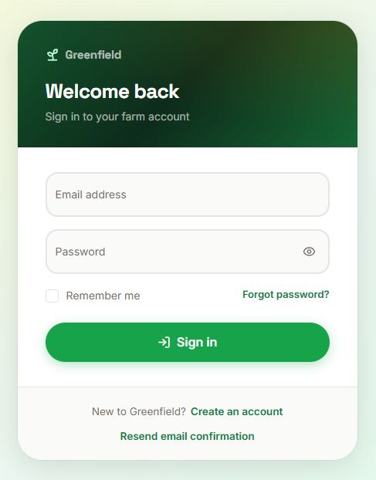
Testing Account Email page as a non logged in user through web address | No test data | The user should be taken to the log-in page | Expected outcome was met and user was taken to the login page | PASS  
Testing Account Password page as a non logged in user through web address | No test data | The user should be taken to the log-in page | Expected outcome was met and user was taken to the login page | PASS  
Testing Account Two Factor Authentication page as a non logged in user through web address | No test data | The user should be taken to the log-in page | Expected outcome was met and user was taken to the login page | PASS  
Testing Personal Data page as a non logged in user through web address | No test data | The user should be taken to the log-in page | Expected outcome was met and user was taken to the login page | PASS  
Testing navigation for Shop the Harvest button on the home page | No test data | Upon clicking, Products page is loaded | Expected outcome was met and Product page loads | PASS  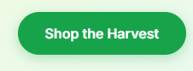  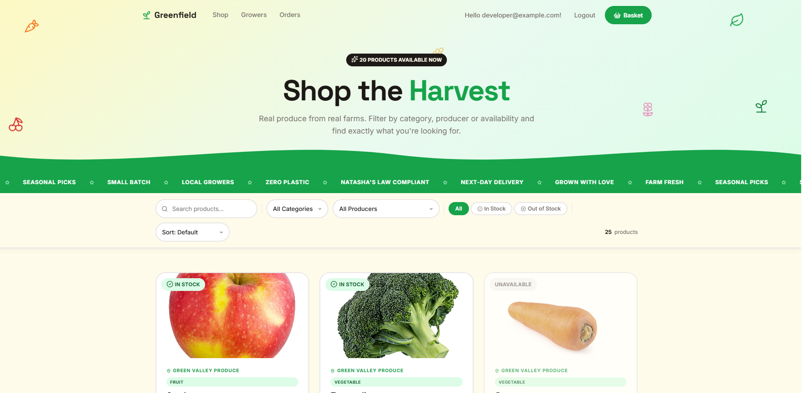
Testing effects for Shop the Harvest button on the home page | No test data | When mouse hovers over button, it should enable a hover effect with a blur behind it | Expected outcome was met, the button hovers with a blur | PASS  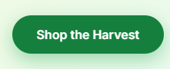
Testing the navigation for Meet our Producers button on the home page | No test data | Upon clicking, Producers page is loaded | Expected outcome was met and Producers page loads | PASS  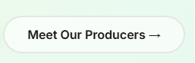  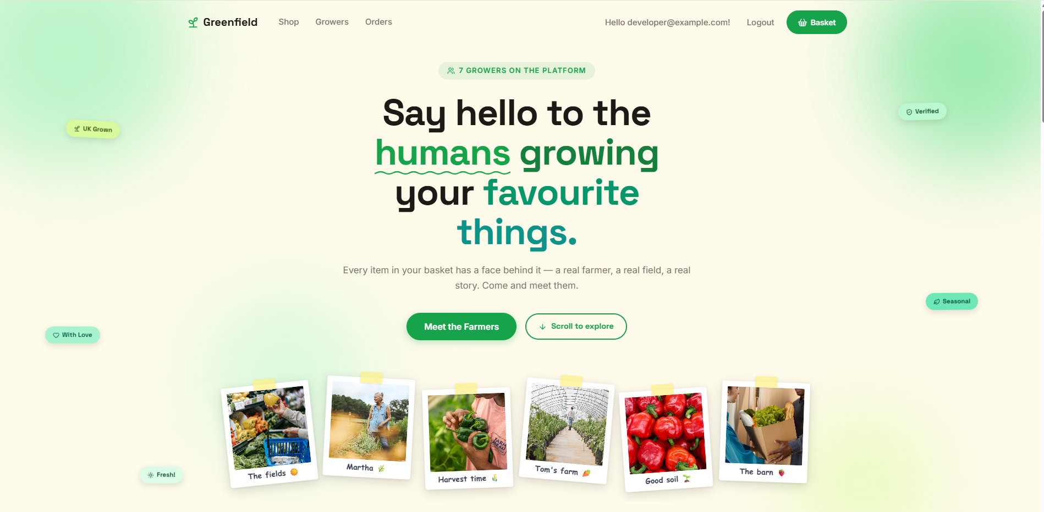
Testing effects for Meet our Producers button on the home page | No test data | When mouse hovers over button, it should enable a hover effect with a green outline around the button | Expected outcome was met, the button hovers with a green outline | PASS  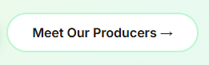
Testing effects for Spring Produce card on the home page | No test data | When mouse hovers over the card, a popping effect plays whilst the mouse is still hovering over the card | Expected outcome was met, the card plays a popping hover effect | PASS  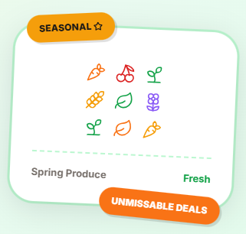
Testing effects for ‘Local UK Farms’ ‘Next-day delivery’ ‘Zero plastic’ text on the home page underneath the Shop the Harvest button | No test data | When mouse hovers over the text, a hover effect plays whilst the mouse is still hovering over it and the text should turn from grey to green | Expected outcome was met, the text individually plays a hover effect | PASS  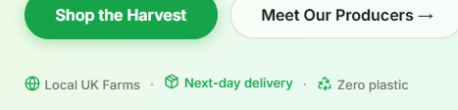
Testing arrow button on home page | No test data | When clicked it should scroll the user down the page to the next section | Expected outcome was met, the user is scrolled down the page | PASS  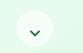
Testing effects arrow button on home page | No test data | When hover over the arrow turns green | Expected outcome was met, the arrow turns green upon mouse hover | PASS  
Testing effects for product cards on home page | No test data | When hovered over by mouse, a hover effect plays individually for each card, zooming in the image and highlight the card being hovered over | Expected outcome was met, hover effect plays individually for each card | PASS  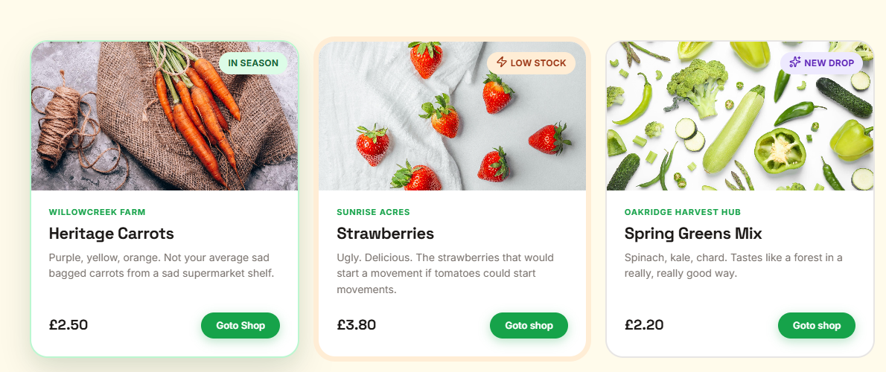
Testing navigation for Goto shop button placed on product cards on the home page | No test data | Upon clicking, Products page is loaded | Expected outcome was met, the Products page loads | PASS  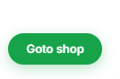  
Testing effects for Goto shop button placed on product cards on the home page | No test data | When mouse hovers over button, it enables a hover effect with a blur behind it | Expected outcome was met, the button hovers with a blur | PASS  
Testing See everything growing button on the home page | No test data | When mouse hovers over button, it enables a hover effect and fills the button with a sage green | Expected outcome was met, the button hovers and fills | PASS  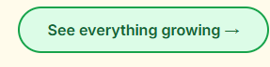
Testing effects for Grab this Deal button on the home page | No test data | When mouse hovers over button, it enables a hover effect with a blur behind it | Expected outcome was met, the button hovers with a blur | PASS  
Testing effects for image at the health bundle section on the home page | No test data | When the mouse is placed on the image, the floating effect pauses until the mouse is moved off and the ‘Just packed’ label does a pop effect and as the mouse moves across the image confetti particles are played | Expected outcome, confetti particles play, pop effect plays and animation temporarily pauses | PASS  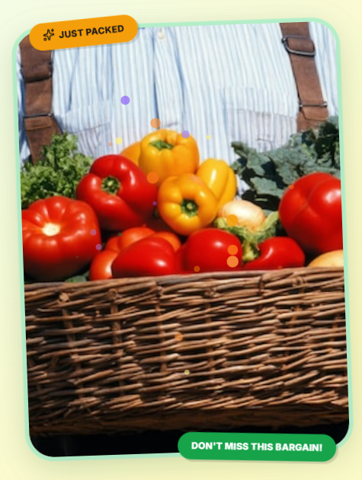
Testing effects for icons in the ‘The process’ section on the homepage | No test data | When the mouse is placed on any of the icons a hover effect should play on that icon, slightly tilting it | Expected outcome, if mouse is placed on the icon it tilts until moved | PASS  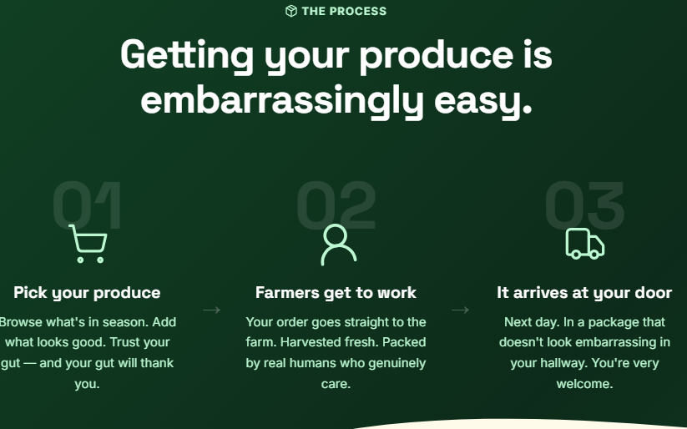
Testing effects for producer cards on the home page | No test data | When the mouse hovers over each producer card the image slightly zooms and has a shadow | Expected outcome, shadow displays and image zooms | PASS  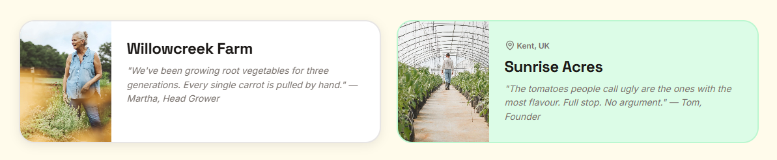
Testing navigation for Meet all our growers button on home page | No test data | Upon clicking, Producers page is loaded | Expected outcome, producers page loads | PASS  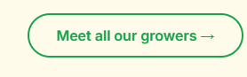  
Testing effects for Meet all our growers button on home page | No test data | When mouse hovers over button, it enables a hover effect and fills the button with a sage green | Expected outcome was met, the button hovers and fills | PASS  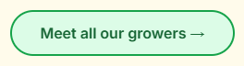
Testing page scrolling | No test data | Scrolling down the page is smooth | Expected outcome was met, smooth scrolling | PASS  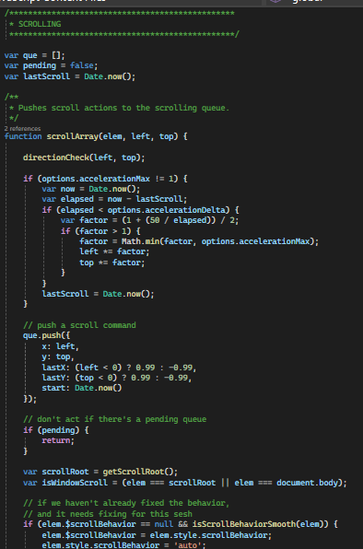
Testing effects of statistics on home page | No test data | As you scroll to the statistic section, each statistic should have an animation which gradually increases the number | Expected outcome was met, the number gradually increases | PASS
Testing navigation on Start Shopping button at the bottom of the home page | No test data | Upon clicking, Products page loads | Expected outcome was met, Products page is loaded | PASS  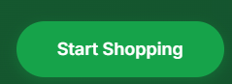
Testing effects on Start Shopping button at the bottom of the home page | No test data | When mouse hovers over button, it enables a hover effect with a blur behind it | Expected outcome was met, the button hovers with a blur | PASS  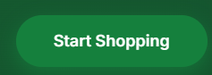
Testing effects on Create Account button at the bottom of the home page | No test data | When mouse hovers over button, it enables a hover effect with a white outline/highlight | Expected outcome was met, the button hovers with a white outline/highlight | PASS  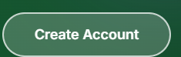
Testing navigation on Create Account button at the bottom of the home page | No test data | Upon clicking, Register page loads | Expected outcome was met, Register page is loaded | PASS  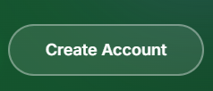
Testing effects for navigation links in the page footer | No test data | When mouse hovers over link, text changes to white | Expected outcome was met, text turns white | PASS  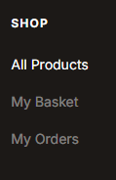
Testing effects for logo in navigation bar | No test data | When mouse hovers over logo, it should lighten or lower in opacity | Expected outcome was met, logo lightens | PASS  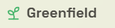
Testing effects for navigation buttons in navigation bar | No test data | When mouse hovers over button, the text turns black and a sage green background appears behind text | Expected outcome was met, turns black and background appears | PASS  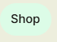
Testing effects for basket button in navigation bar | No test data | When mouse hovers over button, hover effect should play and the button should darken | Expected outcome was met, button hovers and darkens | PASS  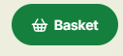
Testing effects for animated sliding details on Products page | No test data | When mouse hovers over, effect will pause | Expected outcome was met, effect pauses | PASS
Testing search bar for products on Products page | Search: Apple | When the product is inputted into the text box, it only finds products which contain those characters | Expected outcome was not met, it would display only one of the products due to scroll-in effects | FAIL  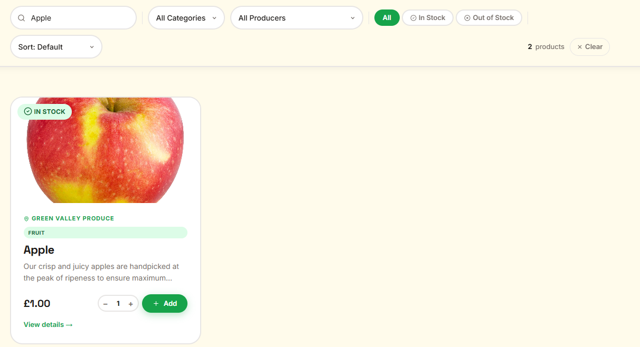  It searches the product but it is only showing one of them, the others areinvisible  FIX  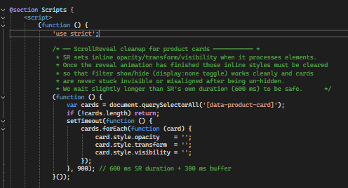  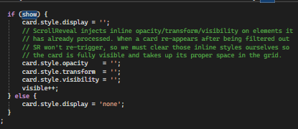  REGRESSION TESTING – PASS  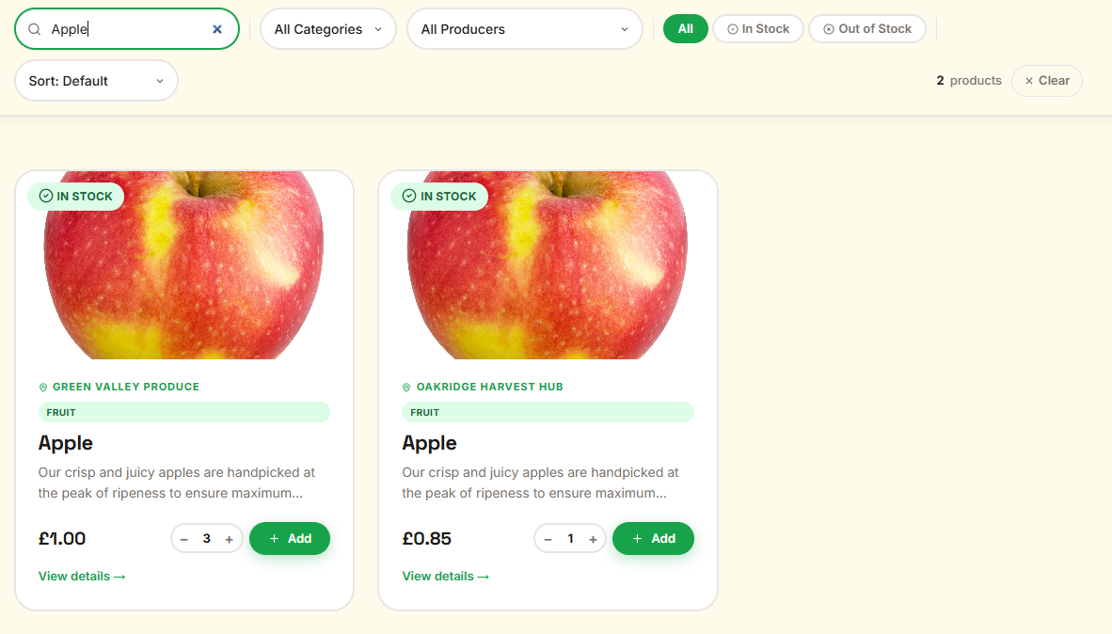
Testing All products filter on Products page | Filter: In Stock ->  Filter: All | Enabled by default, but if clicked from another filter it will display all products | Expected outcome was met, it displays all products | PASS  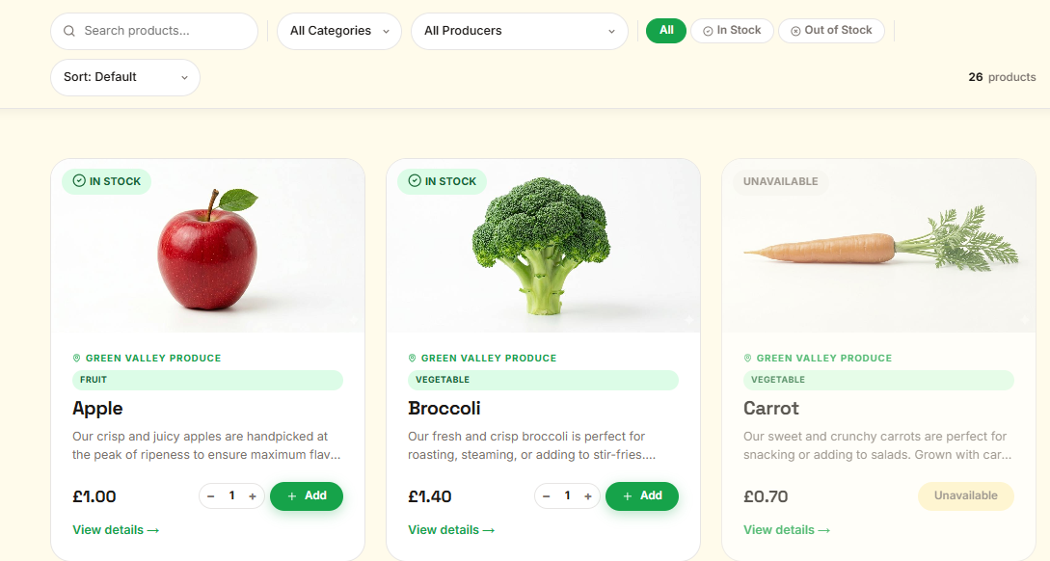
Testing Product categories filter for Dairy product on Products page | Category: Filter: Dairy | It will display only products under the Dairy category | Expected outcome was met, only Dairy product is displayed | PASS  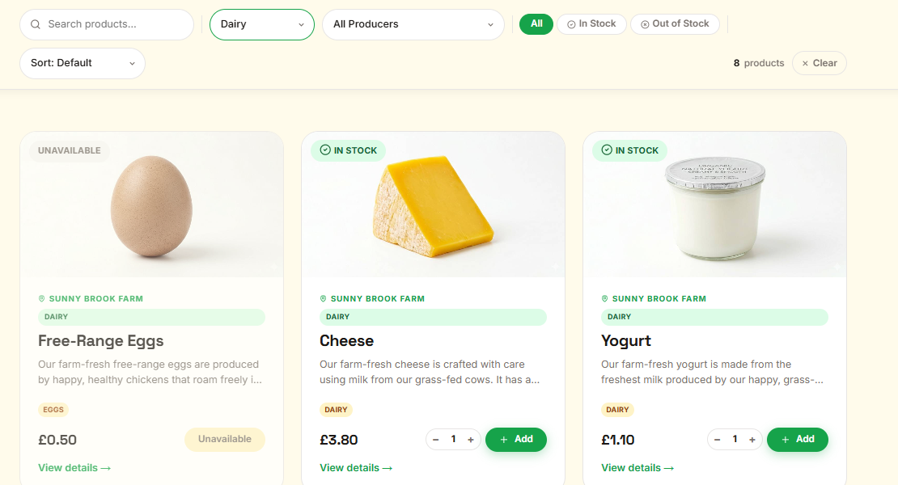
Testing Product categories filter for Fruit product on Products page | Category Filter: Fruit | It will display only products under the Fruit category | Expected outcome was met, only Fruit product is displayed | PASS  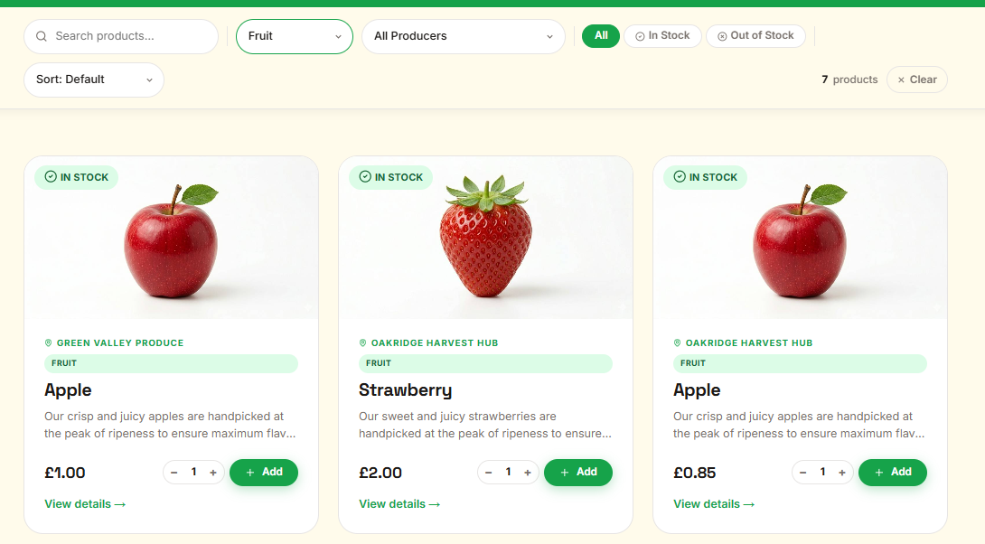
Testing Product categories filter for Meat product on Products page | Category Filter: Meat | It will display only products under the Meat category | Expected outcome was met, only Meat product is displayed | PASS  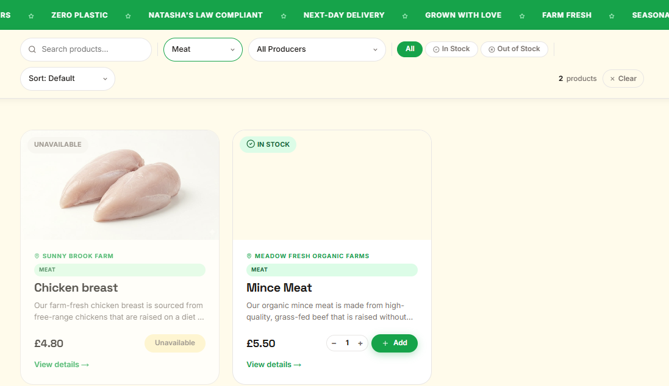
Testing Product categories filter for Vegetable product on Products page | Category Filter: Vegetable | It will display only products under the Vegetable category | Expected outcome was met, only Vegetable product is displayed | PASS  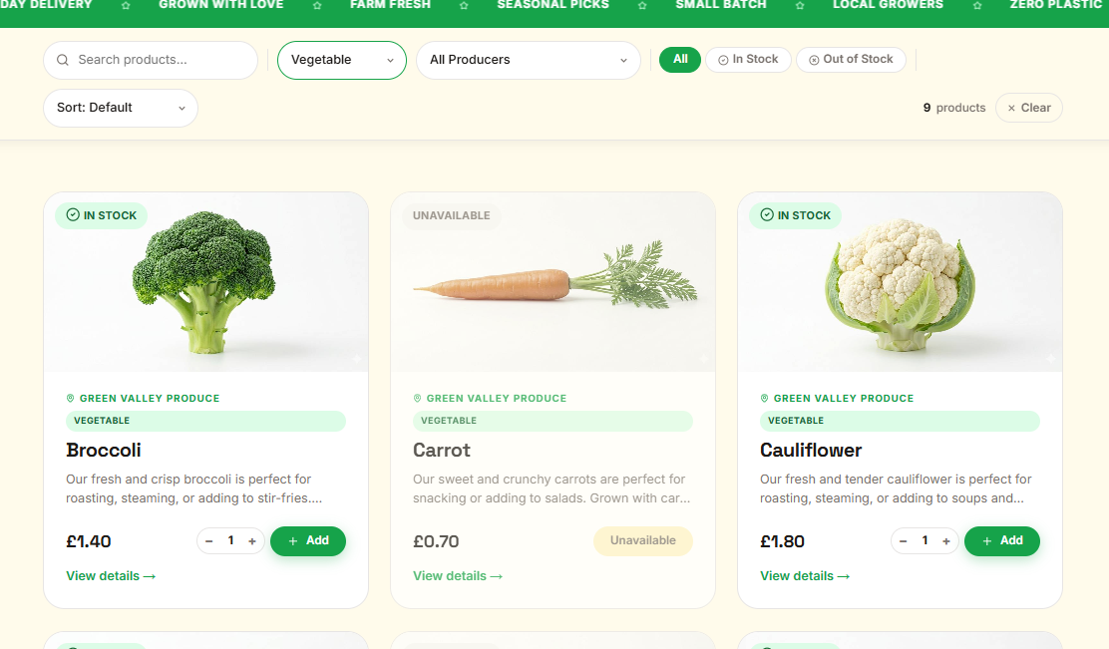
Testing Producer category filter for pre-existing producer on products page | Producer Filter: Green Valley Produce | It will display only products listed by Green Valley Produce | Expected outcome was met, only Green Valley Produce product is displayed | PASS  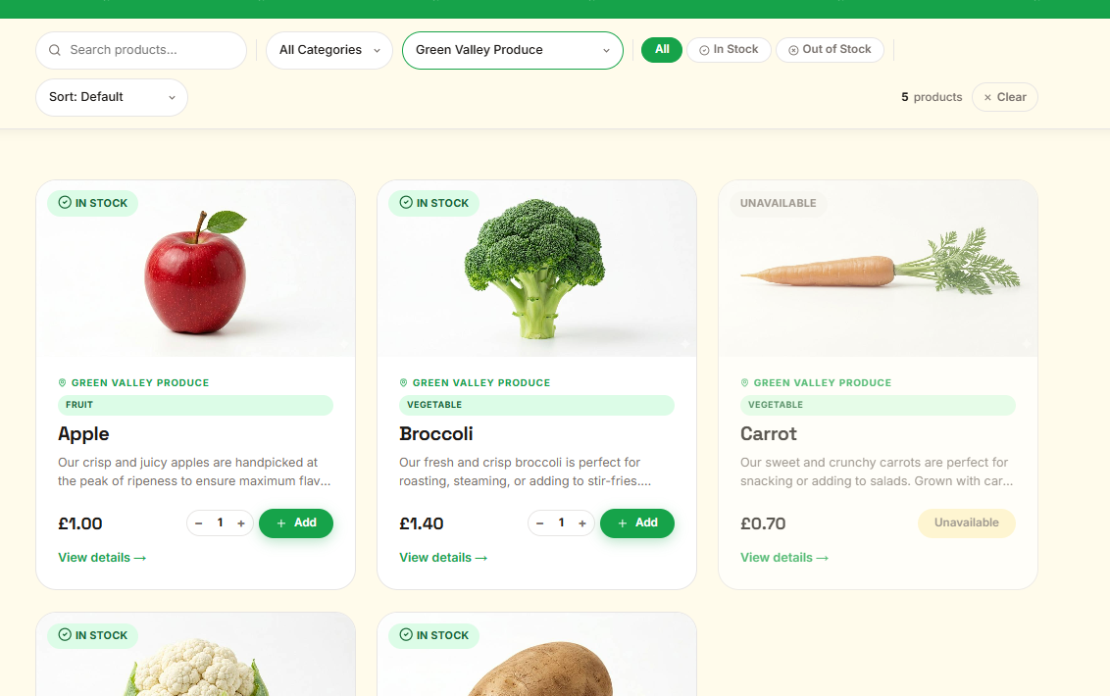
Testing In stock button filter on products page | Stock Filter: In Stock | Once selected, unavailable items are hidden | Expected outcome was met, available products are displayed | PASS  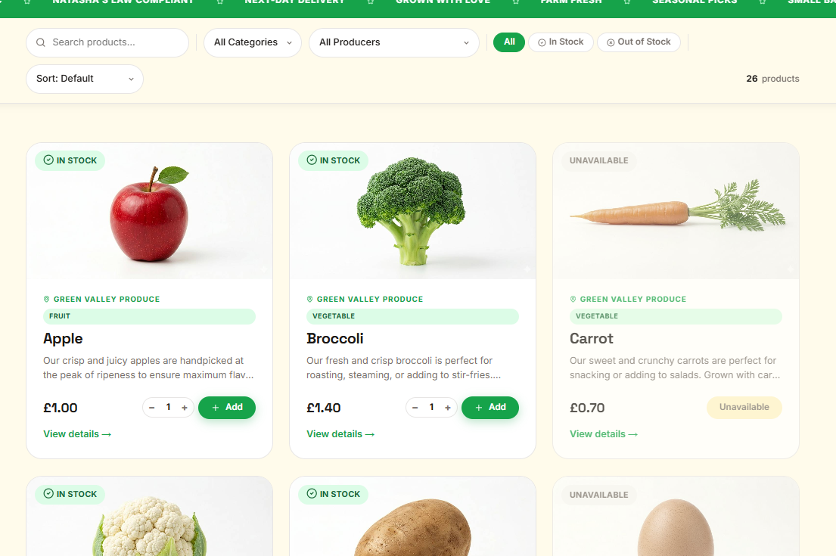
Testing Out of stock button filter on products page | Stock filter: Out of stock | Once selected, only unavailable items are displayed | Expected outcome was met, unavailable products are displayed | PASS  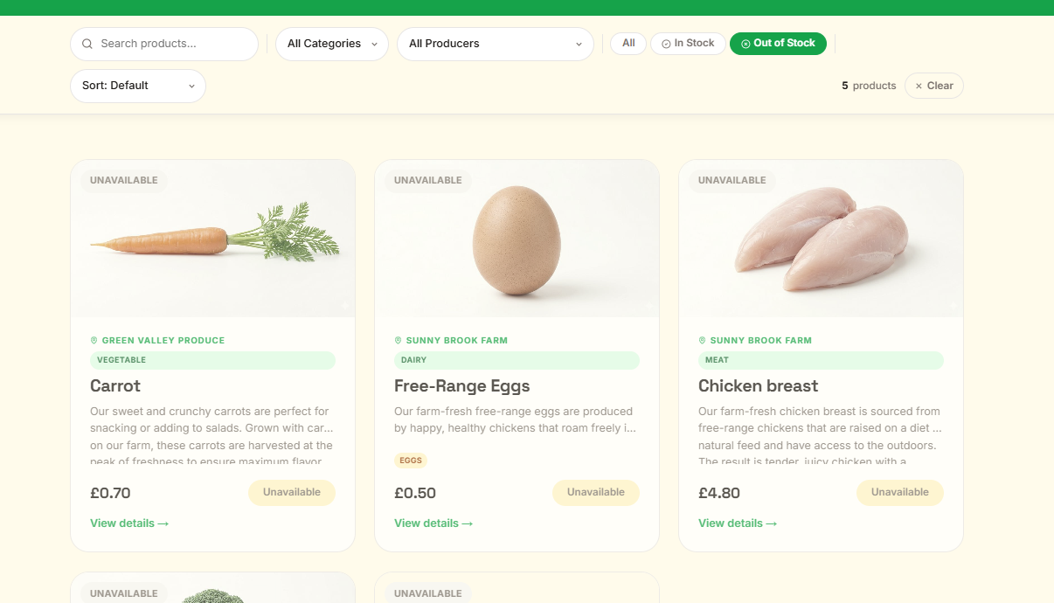
Testing Low to high sort filter on products page | Sort filter: Price: Low -> High | Once selected, lowest priced items are displayed at the top of the product list | Expected outcome was met, cheapest products are at the top | PASS  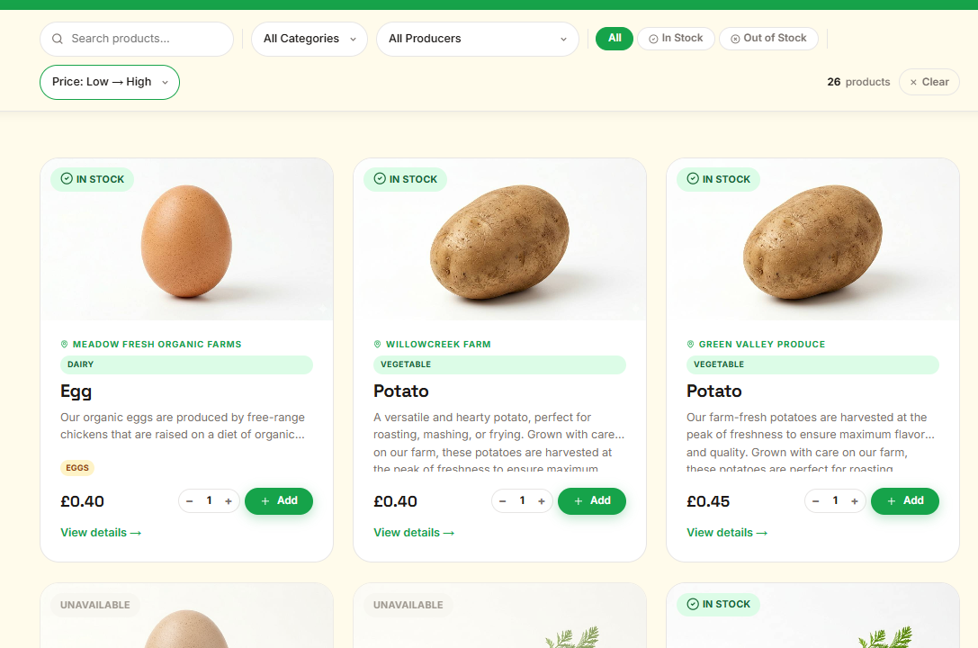
Testing High to low sort filter on products page | Sort filter: Price: High -> Low | Once selected, highest priced items are displayed at the top of the product list | Expected outcome was met, highest valued products are at the top | PASS  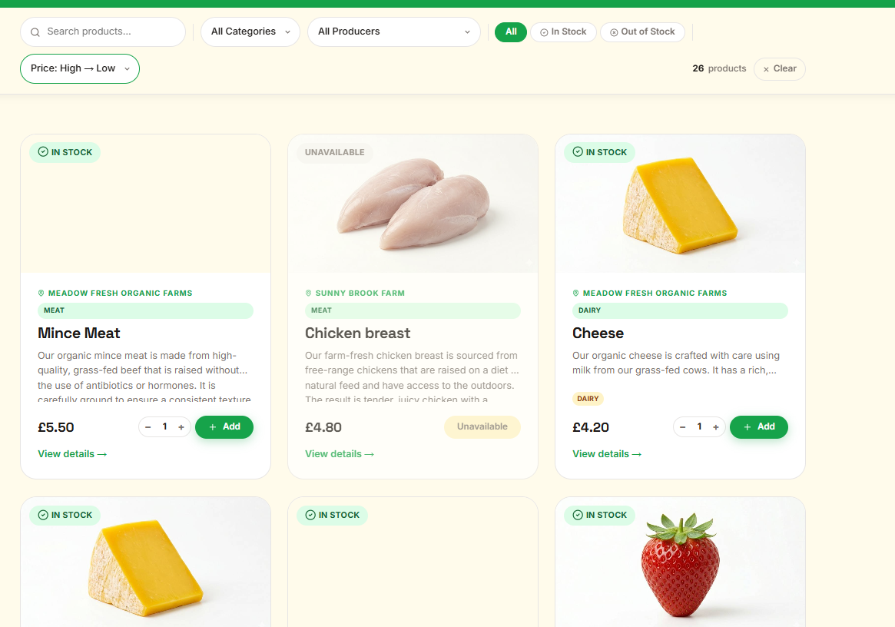
Testing Name A to Z sort filter on products page | Sort filter: Name: A → Z | Once selected, products are displayed alphabetically from A to Z | Expected outcome was met, products are displayed in alphabetical order from A to Z | PASS  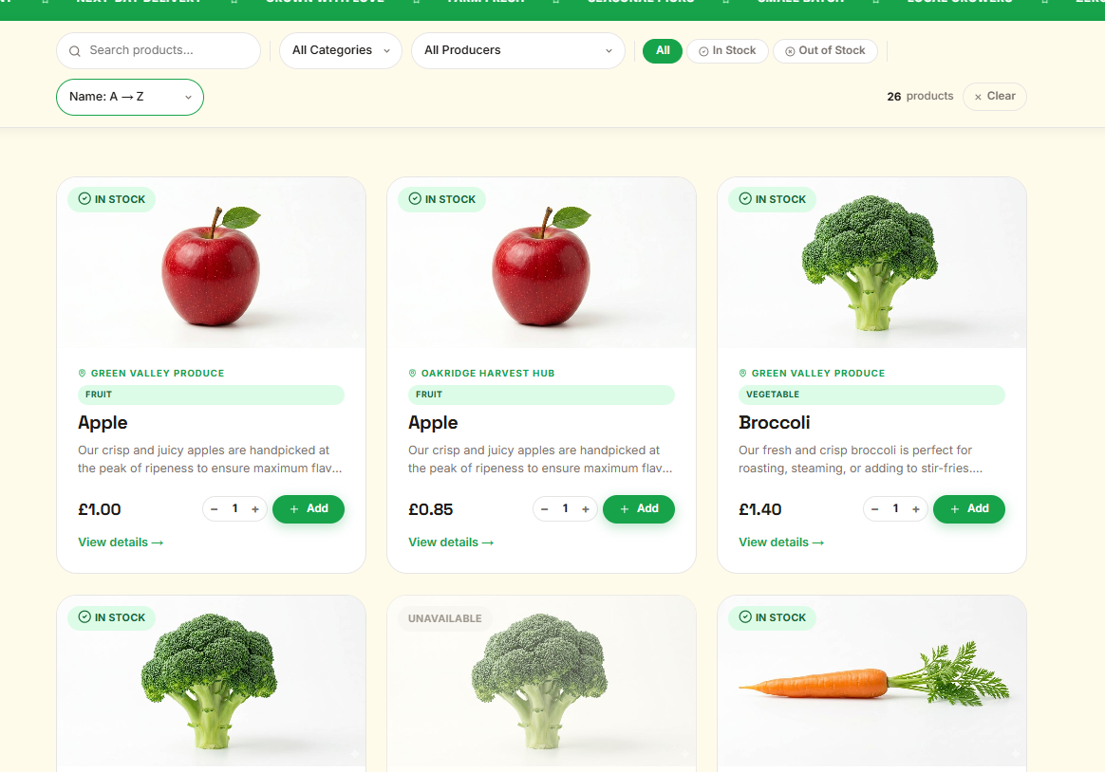
Testing Name Z to A sort filter on products page | Sort filter: Name: Z → A | Once selected, products are displayed in reverse alphabetical order from Z to A | Expected outcome was met, products are displayed in reverse alphabetical order from Z to A | PASS  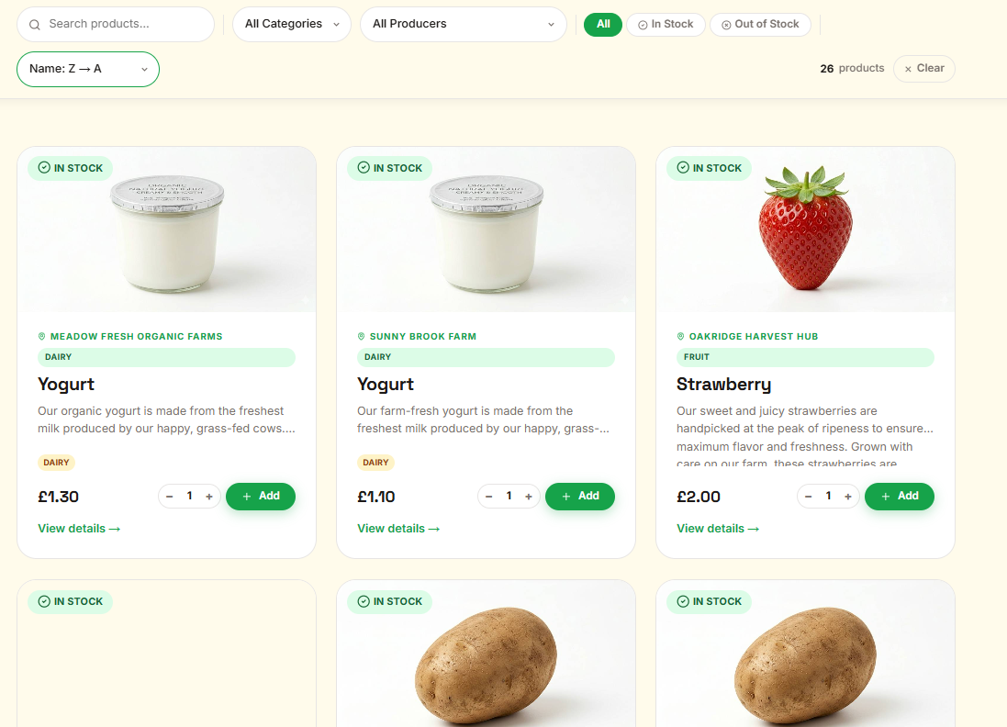
Testing search bar with partial product name on Products page | Search: partial product name e.g. ‘App’ | Only products whose names contain those characters are displayed | Expected outcome was met, only products containing the searched characters are displayed | PASS  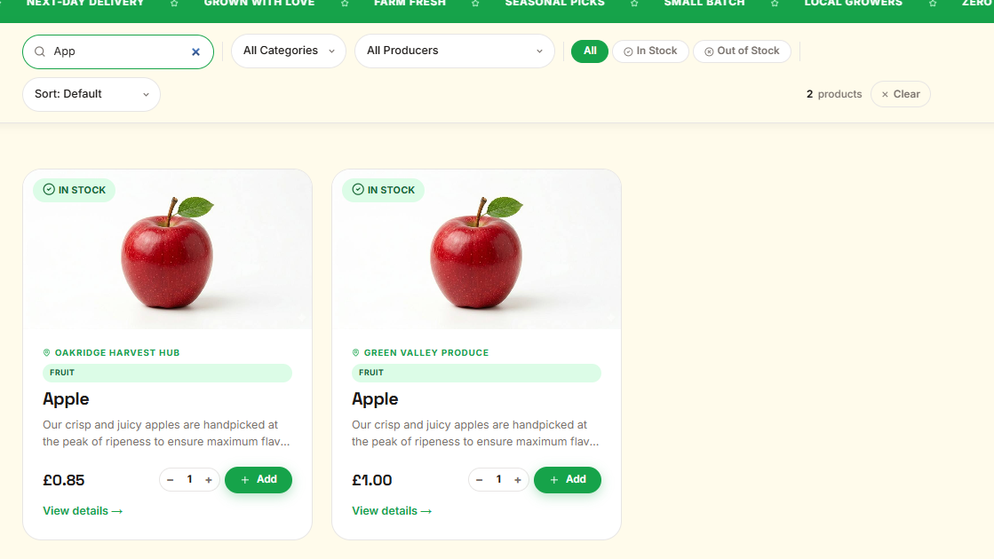
Testing search bar with no matching product name on Products page | Search: a string that matches no products e.g. ‘zzzz’ | No products are displayed and the empty state message is shown | Expected outcome was met, no products are displayed and the empty state is visible | PASS  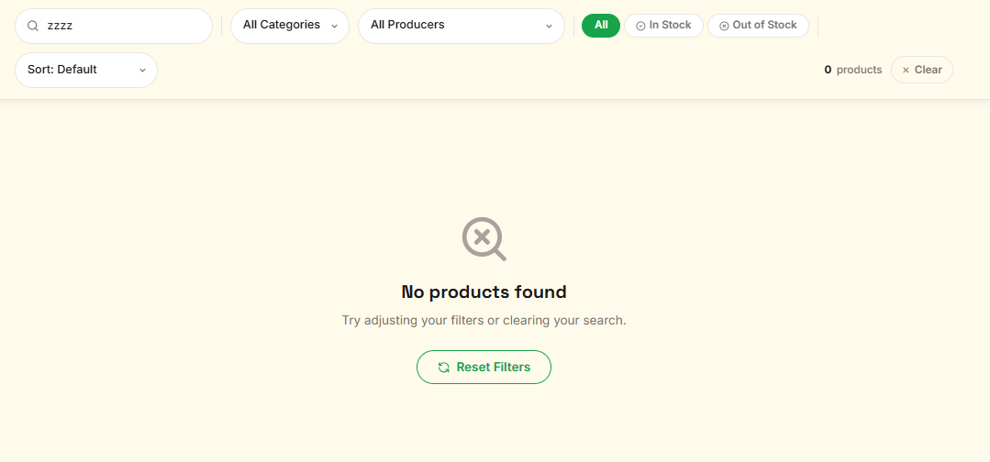
Testing search bar with empty input on Products page | Search: clear the search bar | All products are displayed once the search input is cleared | Expected outcome was met, all products are displayed when search is cleared | PASS  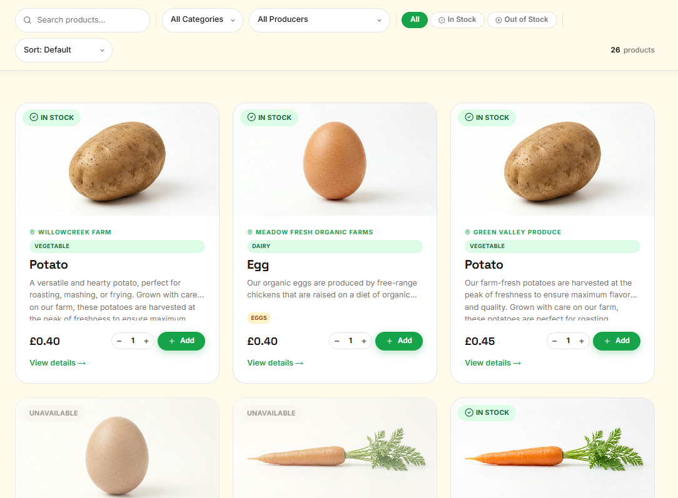
Testing All Categories filter option on Products page | Category Filter: All Categories | All products across every category are displayed | Expected outcome was met, all products are displayed regardless of category | PASS  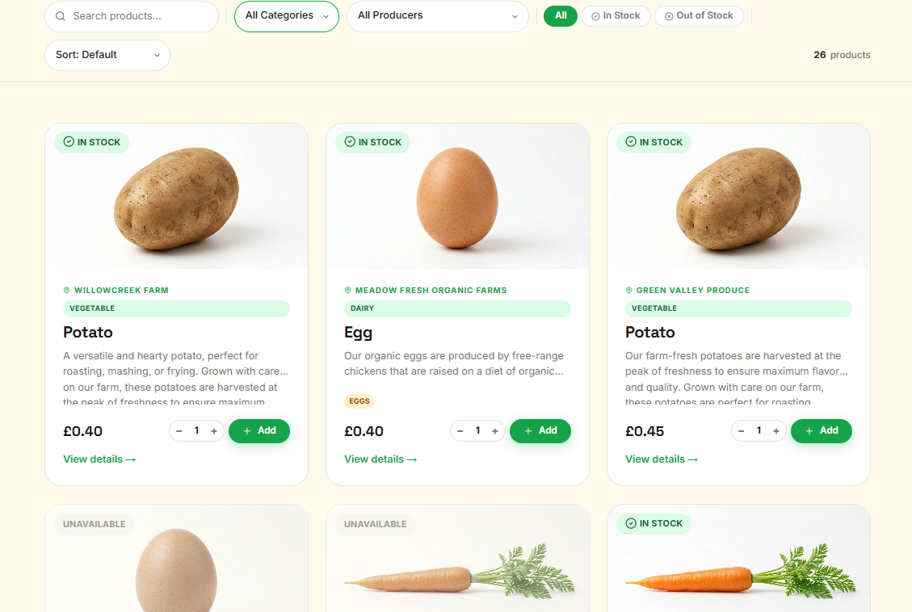
Testing All Producers filter option on Products page | Producer Filter: All Producers | All products from every producer are displayed | Expected outcome was met, all products are displayed regardless of producer | PASS  
Testing combining category filter and producer filter on Products page | Category Filter: Fruit, Producer Filter: Green Valley Produce | Only products that are both under the Fruit category and listed by GreenValley Produce are displayed | Expected outcome was met, only matching products for both filters aredisplayed | PASS  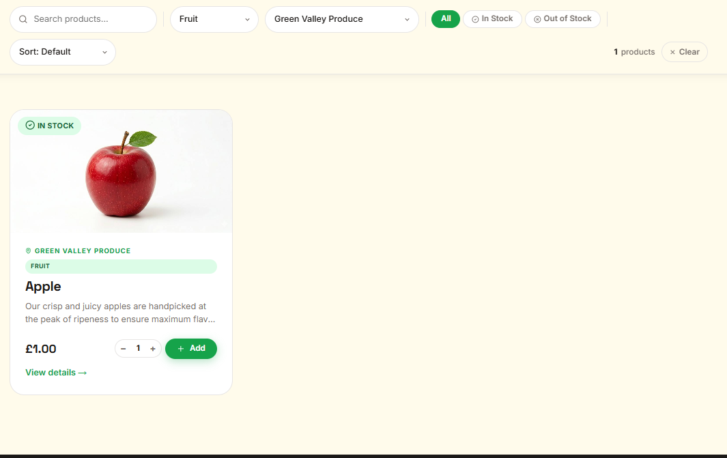
Testing combining search bar and category filter on Products page | Category Filter: Fruit, Search: Apple | Only products under the Fruit category whose name contains the search term are displayed | Expected outcome was met, only the matching filtered and searched product is displayed | PASS  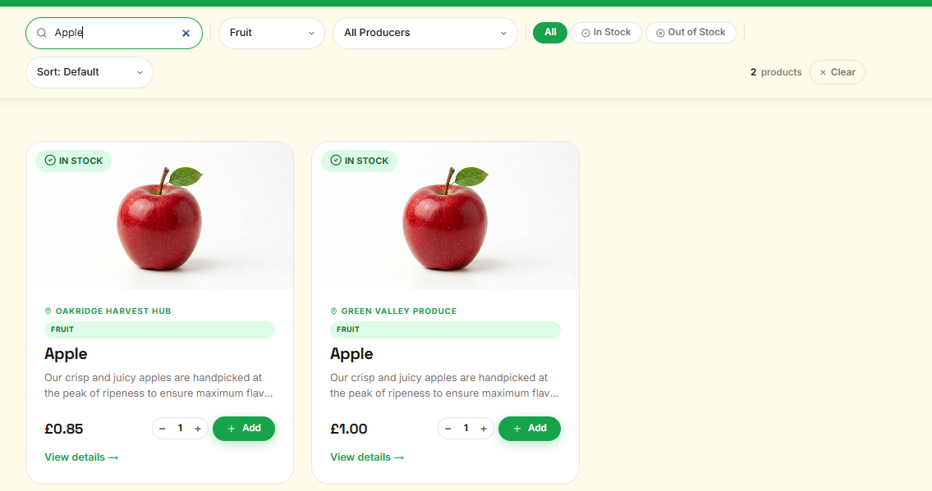
Testing combining availability filter and sort filter on Products page | Stock Filter: In Stock, Sort filter: Price: Low → High | Only in stock products are displayed and they are sorted from lowest to highest price | Expected outcome was met, in stock products are displayed in ascending price order | PASS  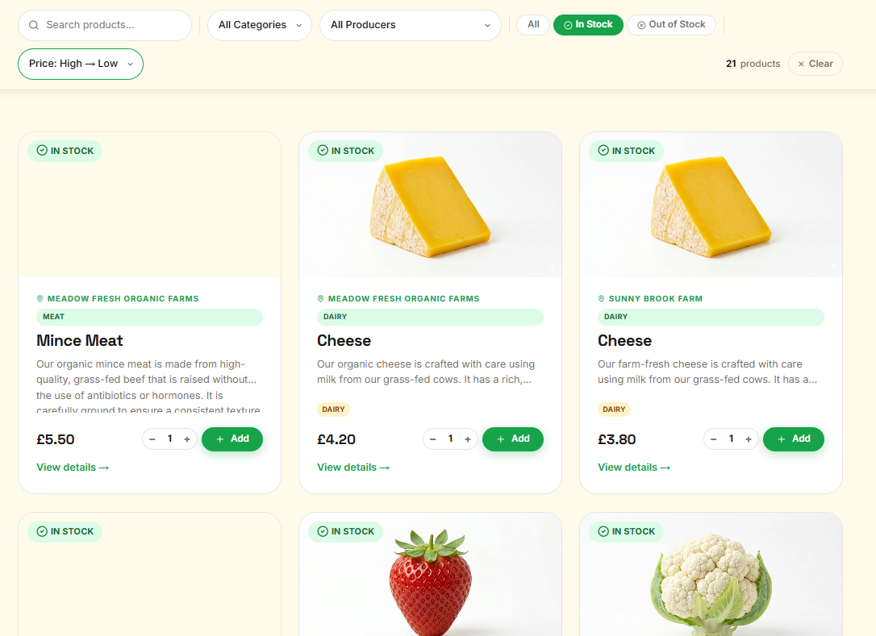
Testing Clear button resets all active filters on Products page | Apply any combination of filters, then click Clear | All active filters are cleared and all products are displayed | Expected outcome was met, clicking Clear resets all filters and displays all products | PASS
Testing Reset Filters button on empty state on Products page | Apply filters that return no results, then click Reset Filters | All filters are cleared and all products are displayed | Expected outcome was met, clicking Reset Filters clears all filters and all products are shown | PASS  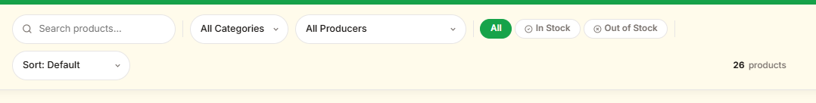
Testing empty state is shown when no products match the applied filters on Products page | Apply filters that return no results | The empty state message is displayed in the product grid | Expected outcome was met, the empty state message is shown when no products match | PASS
Testing Add to basket as a non logged in user by saving via web address on Products page | No test data | An error label is displayed and the item is not added to a basket | Expected outcome was met, an error label is displayed and the item is not added | PASS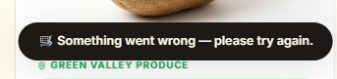
Testing Add to basket as a developer account by saving via web address on Products page | Must be logged in as developer role assigned account | An error label is displayed and the item is not added to a basket | Expected outcome was met, an error label is displayed and the item is not added | PASS
Testing Add to basket as a producer account by saving via web addresson Products page | Must be logged in as producer role assigned account | An error label is displayed and the item is not added to a basket | Expected outcome was met, an error label is displayed and the item is not added | PASS
Testing Add to basket as an admin account by saving via web address on Products page | Must be logged in as admin role assigned account | An error label is displayed and the item is not added to a basket | Expected outcome was met, an error label is displayed and the item is not added | PASS
Testing Add to basket successfully adds a product for a standard logged in user on Products page | Must be logged in as standard user, select any in stock product | The item is added to the basket, a success pop-up confirmation message appears at the bottom of the screen and a confetti burst effect plays on the Add button | Expected outcome was met, the item is added, the pop-up message appears and the confetti burst plays | PASS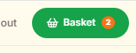
Testing Add to basket button shows a loading spinner whilst the request is processing on Products page | Must be logged in as standard user, click the Add button on any in stock product | The Add button is disabled and displays a loading spinner whilst the request is in progress | Expected outcome was met, the button is disabled and the spinner is displayed during the request | PASS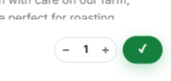
Testing Add to basket button turns green with a tick on successful save action on Products page | Must be logged in as standard user, click the Add button on any in stock product | Once the request succeeds the Add button briefly turns green and shows a tick before reverting | Expected outcome was met, the button turns green with a tick and then reverts after a short delay | PASS
Testing Add to basket pop-up confirmation message appears and disappears on Products page | Must be logged in as standard user, add any in stock product to basket | A pop-up confirmation message slides up from the bottom of the screen confirming the item was added, then fades out after a short delay | Expected outcome was met, the pop-up message appears and fades out correctly | PASS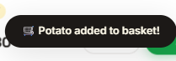
Testing Add to basket pop-up confirmation message shows quantity when more than one item is added on Products page | Must be logged in as standard user, set quantity to more than 1 then click Add | The pop-up confirmation message displays the quantity alongside the item name | Expected outcome was met, the pop-up message shows the quantity and item name correctly | PASS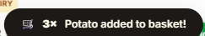
Testing basket label count updates after a product is added on Products page | Must be logged in as standard user, add any in stock product to basket | The basket icon label in the navigation bar updates to reflect the new item count | Expected outcome was met, the basket label count updates correctly | PASS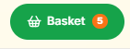
Testing Add to basket button turns red and shows error pop-up message on failed save action on Products page | Must be logged in as standard user, attempt to add a product that triggers a failure response | The Add button turns red and an error pop-up message is displayed at the bottom of the screen | Expected outcome was met, the button turns red and the error pop-up message is displayed | PASS
Testing quantity defaults to 1 on each product card on Products page | No test data | Each product card displays a default quantity of 1 in the quantity control | Expected outcome was met, every product card shows a default quantity of 1 | PASS  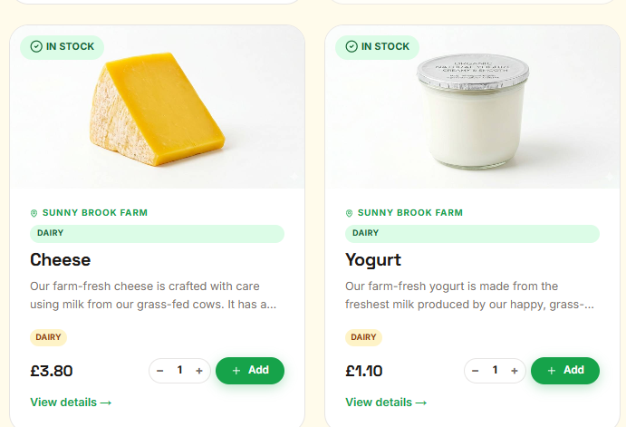
Testing quantity add button increases the quantity on Products page | Click the + button on any in stock product card | The displayed quantity increases by 1 each time the + button is clicked | Expected outcome was met, the quantity increases by 1 on each click | PASS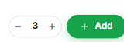
Testing quantity decrease button decreases the quantity on Products page | Set quantity above 1, then click the - button on any in stock product card | The displayed quantity decreases by 1 each time the - button is clicked | Expected outcome was met, the quantity decreases by 1 on each click | PASS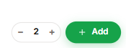
Testing quantity cannot be decremented below 1 on Products page | With quantity at 1, click the - button on any in stock product card | The quantity remains at 1 and does not go below 1 | Expected outcome was met, the quantity stays at 1 and cannot be reduced further | PASS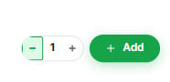
Testing quantity cannot be added above 99 on Products page | No test data | The quantity remains at 99 and does not go higher than 99 | Expected outcome was met and the quantity stays at 99 and cannot be increased further | PASS
Testing View details link navigates to the correct product details page on Products page | No test data | Upon clicking, the correct product’s details page is loaded | Expected outcome was met and the correct product details page is loaded | PASS
Testing View details link is visible to standard logged in users on Products page | Log in as standard user | The View details link is visible on each product card | Expected outcome was met and the View details link is visible on every product card | PASS
Testing View details link is visible to non logged in users on Products page | No test data | The View details link is visible on each product card | Expected outcome was met and the View details link is visible on every product card | PASS
Testing View details link is not shown for producer accounts and is replaced with producer admin controls on Products page | Log in as producer | The View details link is replaced with Details, Edit and Delete producer admin controls on each product card | Expected outcome was met and the producer admin controls replace the View details link | PASS
Testing out of stock product cards display at a low opacity on Products page | No test data | Product cards for out of stock or unavailable items are displayed at a lower opacity | Expected outcome was met and out of stock cards are shown at lower opacity | PASS
Testing out of stock product card images are displayed in greyscale on Products page | No test data | Product images on out of stock or unavailable cards have a partial greyscale filter applied | Expected outcome was met and the images on out of stock cards are shown with a greyscale filter | PASS
Testing the filter bar remains fixed in place below the navigation bar when scrolling on Products page | No test data | When scrolling down the page the filter bar sticks below the navigation bar and stays in place | Expected outcome was met and the filter bar remains fixed in place below the navigation bar while scrolling | PASS
Testing the producer admin management bar is visible for producer accounts on Products page | Log in as producer | A producer management bar is displayed at the top of the product grid with an Add Product button | Expected outcome was met and the producer management bar is displayed with the Add Product button | PASS
Testing the producer admin management bar is not visible for standard logged in users on Products page | Log in as standard user | The producer management bar is not visible | Expected outcome was met and the producer management bar is not shown | PASS
Testing the basket page successfully applies the health bundle discount | Basket with apple, broccoli, carrot | Basket page displays the user the discount is applied to their order in the order summary section | Expected outcome was met and the discount was applied to the order total | PASS
Testing the Create Product page is not accessible to non logged in users | No test data | Trying to open the Create Product page takes you to the login page | Expected outcome was met and accessing the web address loaded the Login page | PASS
Testing the Create Product page is not accessible to standard customer accounts | Log in as standard user | Trying to open the Create Product page loads the Access Denied page | Expected outcome was met and accessing the page loaded the Access Denied page | PASS
Testing the Create Product page is not accessible to admin accounts | Log in as admin | Trying to open the Create Product page loads the Access Denied page | Expected outcome was met and accessing the page loaded the Access Denied page | PASS
Testing the Create Product page is accessible to producer accounts | Log in as producer | The Create Product page loads | Expected outcome was met and the Create Product page loaded | PASS
Testing the Create Product page is accessible to developer accounts | Log in as developer | The Create Product page loads | Expected outcome was met and the Create Product page loaded | PASS
Testing the page title displays correctly on the Create Product page | No test data | The browser tab and page heading display Create Product | Expected outcome was met and the title and heading displayed as expected | PASS
Testing the navigation trail on the Create Product page displays Home, Products, Create | No test data | The navigation trail displays Home / Products / Create in order | Expected outcome was met and the navigation trail displayed in the correct order | PASS
Testing the Home navigation trail link on the Create Product page navigates to the home page | No test data | Upon clicking the Home navigation trail link, the home page is loaded | Expected outcome was met and clicking the Home navigation trail loaded the home page | PASS
Testing the Products navigation trail link on the Create Product page navigates to the products page | No test data | Upon clicking the Products navigation trail link, the Products page is loaded | Expected outcome was met and clicking the Products navigation trail loaded the Products page | PASS
Testing the image preview card shows the placeholder image when no image is selected on the Create Product page | No test data | The image preview area displays the placeholder image and the path label reads no image selected | Expected outcome was met and the placeholder icon and label were displayed | PASS
Testing the Product name field is present and accepts text input on the Create Product page | Product name: Fresh Organic Tomatoes | The Product name input accepts text and displays the typed value | Expected outcome was met and the text was accepted and displayed in the field | PASS
Testing that the product name live preview updates the image card name label as the user types on the Create Product page | Product name: Fresh Organic Tomatoes | As the user types in the Product name field, the name label on the image preview card updates as you type | Expected outcome was met and the name label updated as expected as text was entered | PASS
Testing that the image card name label displays New product when the Product name field is empty on the Create Product page | Product name: cleared / empty | The image preview card name label shows New product when the input is empty | Expected outcome was met and the label reverted to New product when the input was cleared | PASS
Testing the Category dropdown is present and contains all expected options on the Create Product page | No test data | The Category dropdown contains the placeholder plus Vegetables, Fruit, Dairy, Eggs, Meat, Bakery, Honey & Preserves, Herbs & Flowers, Drinks, and Other | Expected outcome was met and all expected category options were present | PASS
Testing the Category dropdown requires a selection on the Create Product page | Save form without selecting a category | A validation error is shown prompting the user to select a category | Expected outcome was met and a validation error was displayed for the Category field | PASS
Testing the Upload image field accepts JPG files on the Create Product page | Upload a .jpg image file | The file is accepted and the image preview card updates to show the uploaded image | Expected outcome was met and the JPG was accepted and the preview updated | PASS
Testing the Upload image field accepts PNG files on the Create Product page | Upload a .png image file | The file is accepted and the image preview card updates to show the uploaded image | Expected outcome was met and the PNG was accepted and the preview updated | PASS
Testing the Upload image field accepts WebP files on the Create Product page | Upload a .webp image file | The file is accepted and the image preview card updates to show the uploaded image | Expected outcome was met and the WebP was accepted and the preview updated | PASS
Testing that the uploaded image overrides the existing image dropdown selection on the Create Product page | No test data | The uploaded file takes priority and the preview displays the uploaded image, not the dropdown selection | Expected outcome was met and the uploaded image was used in the preview instead of the dropdown choice | PASS
Testing the existing image dropdown fills with images from the site image library on the Create Product page | No test data | The existing image dropdown lists the image files available in the the site image library folder | Expected outcome was met and the dropdown was filled with the available images | PASS
Testing that selecting an existing image from the dropdown updates the image preview on the Create Product page | No test data | The image preview card updates to display the selected image and the path label updates to the selected path | Expected outcome was met and the preview and label updated when an existing image was selected | PASS
Testing that clearing the existing image dropdown reverts the preview to the placeholder on the Create Product page | No test data | The image preview card reverts to the placeholder image and the path label reads no image selected | Expected outcome was met and the preview reverted to the placeholder | PASS
Testing the Description text area is present and accepts multi-line input on the Create Product page | Description: multi-line test text | The text field accepts and displays the entered text across multiple lines | Expected outcome was met and multi-line text was accepted and displayed as expected | PASS
Testing the Description field is required and shows a validation error on the Create Product page | Save form with no description entered | A validation error is shown for the Description field | Expected outcome was met and a validation error was displayed | PASS
Testing the Price number control add button increases the price by 0.01 on the Create Product page | No test data | The price input value increases by 0.01 with each click | Expected outcome was met and the price increases by 0.01 | PASS
Testing the Price number control decrement button decreases the price by 0.01 on the Create Product page | Set price above 0.01, then click - on the price number control | The price input value decreases by 0.01 with each click | Expected outcome was met and the price decremented by 0.01 | PASS
Testing the Price number control cannot decrement below the minimum value of 0.01 on the Create Product page | Set price to 0.01 then click the decrement button | The price value remains at 0.01 and does not go below the minimum | Expected outcome was met and the price stayed at the minimum value | PASS
Testing the Quantity number control increase button increases the quantity by 1 on the Create Product page | No test data | The quantity input value increases by 1 with each click | Expected outcome was met and the quantity increases by 1 | PASS
Testing the Quantity number control decrement button decreases the quantity by 1 on the Create Product page | Set quantity above 0, then click - on the quantity number control | The quantity input value decreases by 1 with each click | Expected outcome was met and the quantity decremented by 1 | PASS
Testing the Quantity number control cannot decrement below 0 on the Create Product page | Set quantity to 0 then click the decrement button | The quantity value remains at 0 and does not go below the minimum | Expected outcome was met and the quantity stayed at 0 | PASS
Testing the Listed for sale on/off switch is present and defaults to off on the Create Product page | No test data | The Listed for sale on/off switch is visible and in the off/unchecked state by default | Expected outcome was met and the on/off switch was present and defaulted to off | PASS
Testing the Listed for sale on/off switch can be switched on and off on the Create Product page | No test data | The on/off switch switches between checked and unchecked states on each click | Expected outcome was met and the on/off switch changed state correctly on each click | PASS
Testing allergen tag buttons all 14 allergens are displayed on the Create Product page | No test data | All 14 quick-add allergen tag buttons are visible: Gluten, Milk, Eggs, Peanuts, Tree nuts, Fish, Crustaceans, Sesame, Sulphites, Mustard, Celery, Soybeans, Lupin, Molluscs | Expected outcome was met and all 14 allergen tag buttons were displayed | PASS
Testing that clicking an allergen tag button adds that allergen to the allergen input on the Create Product page | No test data | Gluten is added to the allergen text input field | Expected outcome was met and Gluten appeared in the allergen input | PASS
Testing that clicking an active allergen tag button removes it from the allergen input on the Create Product page | No test data | Gluten is removed from the allergen text input field | Expected outcome was met and Gluten was removed from the input on the second click | PASS
Testing that multiple allergen tag buttons can be selected simultaneously on the Create Product page | No test data | All three allergens appear in the allergen input field separated by commas | Expected outcome was met and all three allergens appeared in the input | PASS
Testing that typing an allergen directly into the allergen input matches the tag button state on the Create Product page | Type Gluten into the allergen input field manually | The Gluten tag button highlights with the is-active class to reflect the manually typed value | Expected outcome was met and the Gluten tag button highlighted after typing it into the input | PASS
Testing that clearing the allergen input deactivates all tag buttons on the Create Product page | No test data | All allergen tag buttons return to their inactive state | Expected outcome was met and all tag buttons deactivated when the input was cleared | PASS
Testing the Back button navigates to the Products main page on the Create Product page | No test data | Upon clicking the Back button the Products main page is loaded | Expected outcome was met and clicking Back loaded the Products main page | PASS
Testing the Create product save button is present on the Create Product page | No test data | The Create product button is visible with a check icon | Expected outcome was met and the button was visible with the icon | PASS
Testing that saving the Create form with all required fields filled saves the product and takes you on the Create Product page | Fill in all required fields with valid data and save | The product is saved and the user is taken to the Products main page | Expected outcome was met and the product was saved and the page change occurred | PASS
Testing that saving the Create form with the Product name field empty shows a validation error on the Create Product page | Leave the Product name field empty and save | A validation error message is shown below the Product name field | Expected outcome was met and the validation error was displayed | PASS
Testing that saving the Create form with the Price field empty shows a validation error on the Create Product page | Leave the Price field empty and save | A validation error message is shown below the Price field | Expected outcome was met and the validation error was displayed | PASS
Testing that the error summary panel appears and lists errors when the form is saved with missing required fields on the Create Product page | Save the form without filling in required fields | The error summary panel becomes visible and lists the field-level errors | Expected outcome was met and the error summary panel appeared with the error list | PASS
Testing the Edit Product page is not accessible to non logged in users | No test data | Trying to open the Edit Product page takes you to the login page | Expected outcome was met and accessing the web address loaded the Login page | PASS
Testing the Edit Product page is not accessible to standard customer accounts | Log in as standard user | Trying to open the Edit Product page loads the Access Denied page | Expected outcome was met and the Access Denied page loaded | PASS
Testing the Edit Product page is not accessible to admin accounts | Log in as admin | Trying to open the Edit Product page loads the Access Denied page | Expected outcome was met and the Access Denied page loaded | PASS
Testing the Edit Product page is accessible to the producer who owns the product | Log in as the producer who owns the product | The Edit Product page loads and shows the product's current data | Expected outcome was met and the Edit page loaded with the correct product data | PASS
Testing the Edit Product page is accessible to developer accounts | Log in as developer | The Edit Product page loads | Expected outcome was met and the Edit page loaded | PASS
Testing the page title displays as Edit followed by the product name on the Edit Product page | No test data | The browser tab and page heading display Edit followed by the product name | Expected outcome was met and the title displayed with the correct product name | PASS
Testing the navigation trail on the Edit Product page displays Home, Shop, product name, Edit | No test data | The navigation trail displays Home / Shop / [Product Name] / Edit in order | Expected outcome was met and the navigation trail displayed in the correct order | PASS
Testing the product name navigation trail link navigates to the product details pageon the Edit Product page | No test data | Upon clicking the product name navigation trail link, the product details pagefor that product is loaded | Expected outcome was met and clicking the product name navigation trail loadedthe correct details page | PASS
Testing all form fields are pre-filled with the existing product data when the Edit Product page loads | Navigate to edit an existing product | All fields including name, category, image path, description, price, quantity, availability and allergens are pre-filled with the product's current values | Expected outcome was met and all fields displayed the correct existing data | PASS
Testing the product name live preview label updates the image card name display as the user edits on the Edit Product page | Edit the product name field | The image card name label updates as you type as the user types | Expected outcome was met and the name label updated as text was entered | PASS
Testing the existing image is displayed in the image preview card when the Edit Product page loads | Navigate to edit a product that has an image set | The image preview card shows the product's current image | Expected outcome was met and the current product image was displayed | PASS
Testing the placeholder image is shown in the image card when the product has no image on the Edit Product page | Navigate to edit a product with no image | The image preview card shows the placeholder image | Expected outcome was met and the placeholder icon was shown | PASS
Testing uploading a new image updates the image preview card on the Edit Product page | Upload a new image file | The image preview card updates to show the newly uploaded image and the path label shows the file name | Expected outcome was met and the preview updated to show the uploaded image | PASS
Testing that selecting a different existing image from the dropdown updates the preview on the Edit Product page | No test data | The image preview updates to show the newly selected image and the path label updates | Expected outcome was met and the preview updated to the selected image | PASS
Testing that the uploaded file overrides the existing image dropdown on the Edit Product page | No test data | The uploaded file takes priority and the preview shows the uploaded image | Expected outcome was met and the uploaded image overrode the dropdown selection | PASS
Testing the Price number control add increases the price correctly on the Edit Product page | No test data | The price increases by 0.01 with each click | Expected outcome was met and the price increased correctly | PASS
Testing the Price number control decrement decreases the price correctly on the Edit Product page | No test data | The price decrements by 0.01 with each click | Expected outcome was met and the price decremented correctly | PASS
Testing the Quantity number control add increases the quantity correctly on the Edit Product page | No test data | The quantity adds by 1 with each click | Expected outcome was met and the quantity increases as expected | PASS
Testing the Quantity number control decrement decreases the quantity correctly on the Edit Product page | No test data | The quantity decrements by 1 with each click | Expected outcome was met and the quantity decremented correctly | PASS
Testing the Quantity number control cannot decrement below 0 on the Edit Product page | Set quantity to 0 then click the decrement button | The quantity remains at 0 | Expected outcome was met and the quantity did not go below 0 | PASS
Testing the Listed for sale on/off switch reflects the product's current availability on the Edit Product page | Navigate to edit a product that is listed | The Listed for sale on/off switch is in the checked/on state | Expected outcome was met and the on/off switch reflected the current available state | PASS
Testing the Listed for sale on/off switch can be toggled on the Edit Product page | No test data | The on/off switch switches state on each click | Expected outcome was met and the on/off switch changed state correctly | PASS
Testing the allergen tag buttons reflect the product's existing allergens on page load on the Edit Product page | Navigate to edit a product that has Gluten and Milk listed as allergens | The Gluten and Milk tag buttons are highlighted with the is-active class on load | Expected outcome was met and both tag buttons were highlighted to reflect the existing allergens | PASS
Testing clicking an inactive allergen tag button adds it to the allergen input on the Edit Product page | No test data | The allergen is added to the allergen input and the tag button highlights | Expected outcome was met and the allergen was added to the input | PASS
Testing clicking an active allergen tag button removes it from the allergen input on the Edit Product page | No test data | The allergen is removed from the allergen input and the tag button unhighlights | Expected outcome was met and the allergen was removed from the input | PASS
Testing the Back button navigates to the Products main page on the Edit Product page | No test data | Upon clicking the Back button the Products main page is loaded | Expected outcome was met and the Products page loaded | PASS
Testing the Save changes button submits the form with valid data and takes you on the Edit Product page | Fill all required fields with valid data and click Save changes | The product is updated and the user is taken | Expected outcome was met and the product was updated and page change occurred | PASS
Testing saving the Edit form with the Product name cleared shows a validation error on the Edit Product page | No test data | A validation error is shown for the Product name field | Expected outcome was met and the validation error was displayed | PASS
Testing saving the Edit form with the Description cleared shows a validation error on the Edit Product page | No test data | A validation error is shown for the Description field | Expected outcome was met and the validation error was displayed | PASS
Testing the error summary panel appears when the Edit form is saved with invalid data on the Edit Product page | Save the form with required fields cleared | The error summary panel becomes visible and lists the errors | Expected outcome was met and the error summary panel was displayed with errors | PASS
Testing the Delete Product page is not accessible to non logged in users | No test data | Trying to open the Delete Product page takes you to the login page | Expected outcome was met and accessing the web address loaded the Login page | PASS
Testing the Delete Product page is not accessible to standard customer accounts | Log in as standard user | Trying to open the Delete Product page loads the Access Denied page | Expected outcome was met and the Access Denied page loaded | PASS
Testing the Delete Product page is not accessible to admin accounts | Log in as admin | Trying to open the Delete Product page loads the Access Denied page | Expected outcome was met and the Access Denied page loaded | PASS
Testing the Delete Product page is accessible to producer accounts | Log in as producer | The Delete Product page loads and shows the product details | Expected outcome was met and the Delete page loaded | PASS
Testing the page title displays as Delete followed by the product name on the Delete Product page | No test data | The browser tab displays Delete - [Product Name] | Expected outcome was met and the title displayed with the correct product name | PASS
Testing the navigation trail on the Delete Product page displays Home, Shop, product name, Delete | No test data | The navigation trail displays Home / Shop / [Product Name] / Delete in order | Expected outcome was met and the navigation trail displayed in the correct order | PASS
Testing the product summary card shows the correct product name on the Delete Product page | Navigate to delete a product | The product name is displayed correctly in the summary card header area | Expected outcome was met and the correct product name was shown | PASS
Testing the product summary card shows the product image when one is set on the Delete Product page | Navigate to delete a product that has an image | The product image is displayed in the summary card header area | Expected outcome was met and the product image was shown | PASS
Testing the product summary card shows a category icon when no image is set on the Delete Product page | Navigate to delete a product that has no image | A category-specific icon is displayed in the summary card header area instead of a product image | Expected outcome was met and the category icon was shown as a fallback | PASS
Testing the summary card displays the correct category and price details line on the Delete Product page | No test data | The details line in the summary header shows [Category] · £[Price] formatted to 2 decimal places | Expected outcome was met and the category and price were displayed as expected | PASS
Testing the In stock label is shown for products with stock available on the Delete Product page | Navigate to delete a product with quantity greater than 0 and Available set to true | A green In stock label showing the remaining quantity is displayed | Expected outcome was met and the In stock label was shown with the correct quantity | PASS
Testing the Out of stock label is shown for products with zero quantity on the Delete Product page | Navigate to delete a product with stock quantity equal to 0 | A red Out of stock label lael is displayed in the summary header | Expected outcome was met and the Out of stock label was displayed | PASS
Testing the Unlisted label label is shown for products where Available is false on the Delete Product page | Navigate to delete a product where Available is false and stock is greater than 0 | An Unlisted label label is displayed in the summary header | Expected outcome was met and the Unlisted label label was shown | PASS
Testing the Contains allergens label is shown when the product has allergens set on the Delete Product page | Navigate to delete a product with allergens | A Contains allergens label with a warning icon is displayed in the summary header | Expected outcome was met and the allergens label was displayed | PASS
Testing the product details rows all show the correct data on the Delete Product page | No test data | The Product name, Category, Price, Stock & availability, Description, Allergens, Image path and Producer rows all display the correct data for the product | Expected outcome was met and all detail rows displayed the correct product information | PASS
Testing the allergen tag buttons row is only shown when the product has allergens on the Delete Product page | Navigate to delete a product with no allergens | The allergens row is not displayed in the product details section | Expected outcome was met and the allergens row was hidden for a product with no allergens | PASS
Testing the allergen tag buttons display as individual tag button spans in the Delete Product page summary | Navigate to delete a product with multiple allergens | Each allergen is displayed as a separate tag button span in the allergen row | Expected outcome was met and each allergen displayed as an individual tag button | PASS
Testing the image path row is only shown when the product has an image set on the Delete Product page | Navigate to delete a product with no image | The image path row is not displayed in the product details section | Expected outcome was met and the image path row was hidden | PASS
Testing the Producer row is only shown when the product has an associated producer on the Delete Product page | Navigate to delete a product linked to a producer | The Producer row is displayed and the producer name is a clickable link to the producer details page | Expected outcome was met and the producer row was displayed with the correct link | PASS
Testing the impact warning panel is displayed on the Delete Product page | No test data | The What will be permanently deleted panel is visible with a warning icon and lists the product listing, basket entries and order records as items to be deleted | Expected outcome was met and the impact warning panel was displayed with all items listed | PASS
Testing the Delete button is disabled by default on the Delete Product page | No test data | The Delete permanently button is displayed with the disabled attribute and disabled state set to true | Expected outcome was met and the button was disabled on page load | PASS
Testing the confirmation checkbox is unchecked by default on the Delete Product page | No test data | The confirmation checkbox is in the unchecked state on page load | Expected outcome was met and the checkbox was unchecked by default | PASS
Testing that checking the confirmation checkbox enables the Delete button on the Delete Product page | Check the I understand... confirmation checkbox | The Delete permanently button becomes enabled and the active class is applied | Expected outcome was met and the button became enabled after the checkbox was checked | PASS
Testing that unchecking the confirmation checkbox disables the Delete button on the Delete Product page | Check then uncheck the confirmation checkbox | The Delete permanently button returns to the disabled state | Expected outcome was met and the button was disabled again when the checkbox was unchecked | PASS
Testing that saving the Delete form permanently removes the product from the database | Check the confirmation checkbox and click Delete permanently | The product is deleted from the database and the user is taken to the Products main page | Expected outcome was met and the product was deleted and the page change occurred | PASS
Testing the Cancel button navigates back to the product Details page on the Delete Product page | No test data | The product Details page for that product is loaded | Expected outcome was met and clicking Cancel loaded the correct Details page | PASS
Testing the Product Details page loads correctly for a valid product ID | Navigate to a valid product details web address | The product details page loads and displays the product information | Expected outcome was met and the product details page loaded | PASS
Testing the Product Details page returns a not found error page for an invalid product ID | Navigate to a product details web address with a non-existent ID | A not found error page or error page is returned | Expected outcome was met and a not found error page or error page was shown for the invalid ID | PASS
Testing the page title displays as the product name on the Product Details page | No test data | The browser tab displays the product name | Expected outcome was met and the title was set to the product name | PASS
Testing the navigation trail displays Home, Shop, Category, product name on the Product Details page | Navigate to a product with a category set | The navigation trail displays Home / Shop / [Category] / [Product Name] in order | Expected outcome was met and all navigation trail segments displayed as expected | PASS
Testing the navigation trail category segment is omitted when the product has no category on theProduct Details page | Navigate to a product with no category | The navigation trail displays Home / Shop / [Product Name] without the category segment | Expected outcome was met and the category segment was not shown | PASS
Testing the product image is displayed in the image card when the product has an image on the Product Details page | Navigate to a product with an image | The product image is displayed in the image card at full aspect ratio | Expected outcome was met and the image was displayed as expected | PASS
Testing the placeholder image is shown in the image card when the product has no image on the Product Details page | Navigate to a product with no image | The image card displays the placeholder image | Expected outcome was met and the placeholder was shown | PASS
Testing the Fresh Pick sticker is shown for in-stock products with sufficient stock on the Product Details page | Navigate to a product that is available with quantity greater than 5 | A green Fresh Pick sticker with a sparkle icon is displayed on the image card | Expected outcome was met and the Fresh Pick sticker was shown | PASS
Testing the Only X left sticker is shown when product has low stock on the Product Details page | Navigate to a product with quantity between 1 and 5 | An orange Only [n] left sticker with a zap icon is shown on the image card | Expected outcome was met and the low stock sticker showed the correct quantity | PASS
Testing the Unavailable sticker is shown when the product is not available on the Product Details page | Navigate to a product where Available is false | A grey Unavailable sticker is shown on the image card | Expected outcome was met and the Unavailable sticker was displayed | PASS
Testing the category sticker is shown in the bottom-right of the image card on the Product Details page | Navigate to a product with a category | A yellow category sticker is shown in the bottom right corner of the image card | Expected outcome was met and the category sticker was shown in the correct position | PASS
Testing the interactive tilt effect and shadow reset when the mouse leaves the image card on the Product Details page | Move the mouse away from the product image card | The card transform and shadow reset to their default values | Expected outcome was met and the card reset on mouse leave | PASS
Testing the Locally grown, Next-day delivery and Zero plastic trust labels are displayed on the Product Details page | No test data | All three trust labels are visible beneath the product image card | Expected outcome was met and all three trust labels were displayed | PASS
Testing the product category label is displayed in the product information section on the Product Details page | Navigate to a product with a category | A green category label is shown at the top of the product information section | Expected outcome was met and the category label was displayed | PASS
Testing the In Stock label is shown for products with sufficient stock in the product information section on the Product Details page | Navigate to an in-stock product with quantity greater than 5 | A green In Stock label with a tick icon is shown | Expected outcome was met and the In Stock label was displayed | PASS
Testing the Low Stock label is shown in the product information section when quantity is 5 or fewer on the Product Details page | Navigate to a product with 1 to 5 units in stock | An orange Low Stock label with a zap icon is shown | Expected outcome was met and the Low Stock label was displayed | PASS
Testing the Out of Stock label is shown in the product information section when quantity is 0 on the Product Details page | Navigate to a product with stock quantity equal to 0 | A red Out of Stock label is shown | Expected outcome was met and the Out of Stock label was displayed | PASS
Testing the Unavailable label is shown in the product information section when Available is false on the Product Details page | Navigate to a product where Available is false | A grey Unavailable label is shown | Expected outcome was met and the Unavailable label was displayed | PASS
Testing the product name heading displays correctly on the Product Details page | No test data | The product name is displayed in the main page heading | Expected outcome was met and the product name heading displayed as expected | PASS
Testing the producer name row is displayed with the location pin icon on the Product Details page | No test data | The By [Producer Name] row with a location pin icon is visible under the product name | Expected outcome was met and the producer row was displayed as expected | PASS
Testing the price block displays the formatted price with GBP symbol on the Product Details page | No test data | The price is shown as £[price] per unit · inc. VAT formatted to 2 decimal places | Expected outcome was met and the price was formatted and displayed as expected | PASS
Testing the product description is displayed on the Product Details page | No test data | The product description text is visible in the product information section | Expected outcome was met and the description was displayed | PASS
Testing the allergen section is displayed when the product has allergens on the Product Details page | Navigate to a product with allergens | The Contains allergens section is shown with individual allergen tag buttons | Expected outcome was met and the allergen section was displayed | PASS
Testing the allergen section is hidden when the product has no allergens on the Product Details page | Navigate to a product with no allergens | The allergens section is not displayed in the product information section | Expected outcome was met and the allergens section was not shown | PASS
Testing each allergen is displayed as an individual tag button on the Product Details page | Navigate to a product with multiple allergens | Each allergen is shown as a separate tag button element | Expected outcome was met and each allergen displayed as an individual tag button | PASS
Testing the In stock and ready to go stock status message is shown for in-stock products on the Product Details page | Navigate to a product with quantity above 5 | The stock status row shows [n] in stock and ready to go with a tick icon | Expected outcome was met and the in-stock message was shown with the correct quantity | PASS
Testing the Only (x amount) left stock status message is shown for low-stock products on the Product Details page | Navigate to a product with 1 to 5 units in stock | The stock status row shows Only (x amount) left with a zap icon | Expected outcome was met and the low-stock message was shown with the correct quantity | PASS
Testing the Out of stock check back soon status message is shown when quantity is 0 on the Product Details page | Navigate to a product with stock quantity equal to 0 | The stock status row shows Out of stock with a cross icon | Expected outcome was met and the out of stock message was shown | PASS
Testing the Currently unavailable status message is shown when Available is false on the Product Details page | Navigate to a product where Available is false | The stock status row shows Currently unavailable from this producer with a cross icon | Expected outcome was met and the unavailable message was shown | PASS
Testing the Add to basket section with quantity controls and Add to Basket button is shown for in-stock products on the Product Details page | Log in as standard user, navigate to an in-stock product | The quantity control with decrement and add buttons and the Add to Basket button are visible | Expected outcome was met and the add to basket controls were displayed | PASS
Testing the Add to basket area is replaced with a disabled Unavailable button for unavailable products on the Product Details page | Navigate to a product where Available is false | A disabled Unavailable button is shown instead of the add to basket controls | Expected outcome was met and the disabled button was shown | PASS
Testing the Add to basket area is replaced with a disabled Out of Stock button when quantity is 0 on the Product Details page | Navigate to a product with quantity equal to 0 | A disabled Out of Stock button is shown instead of the add to basket controls | Expected outcome was met and the disabled Out of Stock button was shown | PASS
Testing the quantity decrement button on the Details page cannot reduce quantity below 1 | No test data | The displayed quantity stays at 1 and does not go below 1 | Expected outcome was met and the quantity stayed at 1 | PASS
Testing the quantity add button on the Details page cannot increase quantity above 99 | Increase quantity to 99 and click add again | The displayed quantity stays at 99 | Expected outcome was met and the quantity stayed at 99 | PASS
Testing the Add to Basket button shows a loading spinner while the background request is in progress on the Product Details page | Log in as standard user, click Add to Basket | The button is disabled and displays a spinner while the request processes | Expected outcome was met and the spinner was displayed during the request | PASS
Testing the Add to Basket button turns green with a tick on a successful background request on the Product Details page | Log in as standard user, add an in-stock product to the basket | The button turns green and displays a tick before reverting | Expected outcome was met and the button turned green with a tick after success | PASS
Testing the basket label in the navigation bar updates after a successful Add to Basket on the Product Details page | Log in as standard user, add an in-stock product to the basket | The basket label count in the navigation bar updates to reflect the new total | Expected outcome was met and the label count updated correctly | PASS
Testing a confetti burst effect plays from the Add to Basket button on a successful save action on the Product Details page | Log in as standard user, add an in-stock product to basket | Coloured confetti particles burst outward from the Add to Basket button after a successful add | Expected outcome was met and the confetti burst played after the item was added | PASS
Testing the Add to Basket success pop-up confirmation message appears and auto-dismisses on the Product Details page | Log in as standard user, add an in-stock product to basket | A pop-up confirmation message appears confirming the item was added then fades out after approximately 2.8 seconds | Expected outcome was met and the pop-up message appeared and dismissed correctly | PASS
Testing the Add to Basket success pop-up message shows the quantity when more than 1 is added on the Product Details page | Set quantity to 3 and click Add to Basket | The pop-up message shows 3x [Product Name] added to basket! | Expected outcome was met and the pop-up message displayed the quantity correctly | PASS
Testing the Add to Basket button turns red and shows an error pop-up message on a failed request on the Product Details page | Trigger a server-side failure for the add to basket request | The button briefly turns red and an error pop-up message is displayed | Expected outcome was met and the button turned red and the error pop-up message appeared | PASS
Testing that a failed Add to Basket request re-enables the button and restores its original HTML on the Product Details page | Trigger a server-side failure | The Add to Basket button is re-enabled and its label reverts to its original state | Expected outcome was met and the button was restored after the failure | PASS
Testing the producer info card is displayed with the producer name and bio on theProduct Details page | Navigate to a product linked to a producer with bio information | The producer card shows the producer name, a truncated bio and a See alltheir products link | Expected outcome was met and the producer card was displayed with thecorrect information | PASS
Testing the See all their products link navigates to the Producers main page on the Product Details page | No test data | The Producers main page is loaded | Expected outcome was met and the Producers page loaded | PASS
Testing the producer admin controls are visible on the Product Details page for producer accounts | Log in as producer | The Edit and Delete admin links and the Back to my products link are displayed below the producer card | Expected outcome was met and the producer admin links were visible | PASS
Testing the producer admin controls are not visible for standard customer accounts on the Product Details page | Log in as standard user | The producer Edit and Delete admin links are not displayed | Expected outcome was met and the admin controls were not shown for standard customers | PASS
Testing the producer admin controls are not visible for non logged in users on the Product Details page | No test data | The producer Edit and Delete admin links are not displayed | Expected outcome was met and the admin controls were not shown to non logged in users | PASS
Testing the Edit admin link navigates to the Edit Product page on the Product Details page | Log in as producer, click the Edit link | The Edit Product page for this product is loaded | Expected outcome was met and the Edit page loaded | PASS
Testing the Delete admin link navigates to the Delete Product page on the Product Details page | Log in as producer, click the Delete link | The Delete Product page for this product is loaded | Expected outcome was met and the Delete page loaded | PASS
Testing the Back to shop link is shown for non-producer users on the Product Details page | Log in as standard user or view as non logged in | A Back to shop link is visible below the producer card | Expected outcome was met and the Back to shop link was shown | PASS
Testing the More from this producer section is displayed when other products from the same producer exist on the Product Details page | Navigate to a product whose producer has other listed products | The More from [Producer Name] section is shown below the main product section | Expected outcome was met and the more from producer section was displayed | PASS
Testing the More from this producer section is hidden when the product is the only one from that producer on the Product Details page | Navigate to a product whose producer has no other products | The More from this producer section is not displayed | Expected outcome was met and the section was hidden | PASS
Testing the related product cards in the More from this producer section display stock labels correctly on the Product Details page | Navigate to a product whose producer has both in-stock and out-of-stock related products | Each related card shows the correct stock label matching its availability state | Expected outcome was met and the correct labels were shown on each related card | PASS
Testing the Add to Basket popping animation works correctly on related product cards in the More from this producer section on the Product Details page | Log in as standard user, click Add on a related product card | The item is added to the basket, popping animation plays and the basket label updates | Expected outcome was met and the basket was updated and the animation appeared | PASS
Testing the View details link on related product cards navigates to the correct product page on the ProductDetails page | No test data | The correct product details page for that product is loaded | Expected outcome was met and the correct product page loaded | PASS
Testing the See all products button in the More from this producer section navigates you to the Products main listing on the Product Details page | No test data | The Products main page is loaded | Expected outcome was met and the Products page loaded | PASS
Testing the Orders page is not accessible to non logged in users | No test data | Trying to open the Orders page takes you to the login page | Expected outcome was met and attempting to access the Orders page took the user to the login page | PASS
Testing the Orders page is accessible to standard customer accounts | Log in as standard user | The Orders page loads and displays that customer's orders | Expected outcome was met and the Orders page loaded and displayed that customer's orders | PASS
Testing the Orders page is accessible to admin accounts | Log in as admin | The Orders page loads and displays all orders across every customer | Expected outcome was met and the Orders page loaded and displayed all orders across every customer | PASS
Testing the Orders page is accessible to producer accounts | Log in as producer | The Orders page loads and displays orders containing that producer's products | Expected outcome was met and the Orders page loaded and displayed orders containing that producer's products | PASS
Testing the Orders page shows the correct heading for a standard customer | Log in as standard user | The page heading displays Your Orders and the badge reads Order History | Expected outcome was met and the page heading displayed Your Orders and the badge reads Order History | PASS
Testing the Orders page shows the correct heading for an admin | Log in as admin | The page heading displays Order Dashboard and the badge reads Admin - All Orders | Expected outcome was met and the page heading displayed Order Dashboard and the badge reads Admin - All Orders | PASS
Testing the Orders page shows the correct heading for a producer | Log in as producer | The page heading displays Your Orders and the badge reads Producer Dashboard | Expected outcome was met and the page heading displayed Your Orders and the badge reads Producer Dashboard | PASS
Testing the stats bar shows the correct total order count on the Orders page | Log in as standard user with existing orders | The Total Orders stat displays the correct number of orders for that account | Expected outcome was met and the Total Orders stat displayed the correct number of orders for that account | PASS
Testing the stats bar shows the correct active order count on the Orders page | Log in as standard user with at least one non-delivered order | The Active stat displays the correct count of orders not yet marked as Delivered | Expected outcome was met and the Active stat displayed the correct count of orders not yet marked as Delivered | PASS
Testing the stats bar shows the correct total spent on the Orders page | Log in as standard user with existing orders | The Total Spent stat displays the correct sum of all order totals formatted to 2 decimal places | Expected outcome was met and the Total Spent stat displayed the correct sum of all order totals formatted to 2 decimal places | PASS
Testing the Free Delivery stat is shown for standard customers on the Orders page | Log in as standard user | The Free Delivery stat is visible and shows either the number of orders away or Next order! when eligible | Expected outcome was met and the Free Delivery stat was visible and showed either the number of orders away or Next order! when eligible | PASS
Testing the Free Delivery stat is not shown for admin accounts on the Orders page | Log in as admin | The Free Delivery stat is not displayed in the stats bar | Expected outcome was met and the Free Delivery stat was not displayed in the stats bar | PASS
Testing the Free Delivery stat is not shown for producer accounts on the Orders page | Log in as producer | The Free Delivery stat is not displayed in the stats bar | Expected outcome was met and the Free Delivery stat was not displayed in the stats bar | PASS
Testing the empty state is shown when the account has no orders on the Orders page | Log in as account with no orders placed | The No orders yet message is displayed along with a Shop the Harvest button | Expected outcome was met and the No orders yet message was displayed along with a Shop the Harvest button | PASS
Testing the Shop the Harvest button on the empty state navigates to the Products page | Log in as account with no orders placed | Upon clicking Shop the Harvest, the Products page is loaded | Expected outcome was met and upon clicking Shop the Harvest, the Products page loaded | PASS
Testing the search bar filters orders by order number on the Orders page | Search: enter the full order number e.g. PF-000001 | Only orders whose reference matches the search are displayed | Expected outcome was met and only orders whose reference matched the search are displayed | PASS
Testing the search bar filters orders using a partial order number on the Orders page | Search: enter a partial order number e.g. 000 | All orders whose reference contains those characters are displayed | Expected outcome was met and all orders whose reference contains those characters are displayed | PASS
Testing the search bar with no matching order number shows the no results state on the Orders page | Search: enter a string that matches no orders e.g. zzzz | No order cards are shown and the No orders match empty state is displayed | Expected outcome was met and no order cards are shown and the No orders match empty state was displayed | PASS
Testing clearing the search bar restores all orders on the Orders page | No test data | All orders are shown again once the search input is cleared | Expected outcome was met and all orders are shown again once the search input is cleared | PASS
Testing the Most Recent sort option on the Orders page | Sort: Most Recent | Orders are displayed with the most recently placed order first | Expected outcome was met and orders are displayed with the most recently placed order first | PASS
Testing the Oldest First sort option on the Orders page | Sort: Oldest First | Orders are displayed with the oldest placed order first | Expected outcome was met and orders are displayed with the oldest placed order first | PASS
Testing the Highest Value sort option on the Orders page | Sort: Highest Value | Orders are displayed with the highest order total first | Expected outcome was met and orders are displayed with the highest order total first | PASS
Testing the Lowest Value sort option on the Orders page | Sort: Lowest Value | Orders are displayed with the lowest order total first | Expected outcome was met and orders are displayed with the lowest order total first | PASS
Testing the All filter shows every order on the Orders page | Filter: All | All order cards are displayed regardless of their status | Expected outcome was met and all order cards are displayed regardless of their status | PASS
Testing the Pending filter shows only pending orders on the Orders page | Filter: Pending | Only order cards with a Pending status are displayed | Expected outcome was met and only order cards with a Pending status are displayed | PASS
Testing the Preparing filter shows only orders being prepared on the Orders page | Filter: Preparing | Only order cards with a Preparing Delivery status are displayed | Expected outcome was met and only order cards with a Preparing Delivery status are displayed | PASS
Testing the Awaiting filter shows only orders awaiting confirmation on the Orders page | Filter: Awaiting | Only order cards with an Awaiting Confirmation status are displayed | Expected outcome was met and only order cards with an Awaiting Confirmation status are displayed | PASS
Testing the Delivered filter shows only delivered orders on the Orders page | Filter: Delivered | Only order cards with a Delivered status are displayed | Expected outcome was met and only order cards with a Delivered status are displayed | PASS
Testing the Clear filters button resets all active filters on the Orders page | Apply any filter and search term, then click Clear filters | All filters are cleared and all orders are shown again | Expected outcome was met and all filters are cleared and all orders are shown again | PASS
Testing order cards show the correct order reference, status and total on the Orders page | Log in as standard user with existing orders | Each order card displays the formatted order reference, status and order total correctly | Expected outcome was met and each order card displayed the formatted order reference, status and order total correctly | PASS
Testing order cards show the correct order date and fulfilment method on the Orders page | Log in as standard user with both delivery and collection orders | Cards show the order date, and either Delivery or Collection with the relevant method detail | Expected outcome was met and cards show the order date, and either Delivery or Collection with the relevant method detail | PASS
Testing the Details button on each order card navigates to the correct Order Details page | No test data | Upon clicking, the correct order's Details page is loaded | Expected outcome was met and upon clicking, the correct order's Details page loaded | PASS
Testing the Re-order button is visible to standard customer accounts on the Orders page | Log in as standard user | The Re-order button is visible on each order card | Expected outcome was met and the Re-order button was visible on each order card | PASS
Testing the Re-order button is not visible to admin accounts on the Orders page | Log in as admin | The Re-order button is not displayed on any order card | Expected outcome was met and the Re-order button was not displayed on any order card | PASS
Testing the Re-order button is not visible to producer accounts on the Orders page | Log in as producer | The Re-order button is not displayed on any order card | Expected outcome was met and the Re-order button was not displayed on any order card | PASS
Testing the Edit and Delete buttons are visible to admin accounts on the Orders page | Log in as admin | The Edit and Delete buttons are visible on each order card | Expected outcome was met and the Edit and Delete buttons are visible on each order card | PASS
Testing the Edit and Delete buttons are not visible to standard customer accounts on the Orders page | Log in as standard user | The Edit and Delete buttons are not displayed on any order card | Expected outcome was met and the Edit and Delete buttons are not displayed on any order card | PASS
Testing the Confirm Delivery button is shown for orders awaiting confirmation on the Orders page | Log in as standard user with an order at Awaiting Confirmation status | The Confirm Delivery button is visible on the relevant order card | Expected outcome was met and the Confirm Delivery button was visible on the relevant order card | PASS
Testing the Confirm Delivery button successfully marks the order as delivered on the Orders page | Log in as standard user, click Confirm Delivery on an eligible order | The order status updates to Delivered and the Confirm Delivery button is no longer shown | Expected outcome was met and the order status updated to Delivered and the Confirm Delivery button is no longer shown | PASS
Testing the Checkout page is not accessible to non logged in users | No test data | Trying to open the Checkout page takes you to the login page | Expected outcome was met and attempting to access the Checkout page took the user to the login page | PASS
Testing the Checkout page is not accessible to producer accounts | Log in as producer | Trying to open the Checkout page loads the Access Denied page | Expected outcome was met and attempting to access the Checkout page via web address loaded the Access Denied page | PASS
Testing the Checkout page is not accessible to admin accounts | Log in as admin | Trying to open the Checkout page loads the Access Denied page | Expected outcome was met and attempting to access the Checkout page via web address loaded the Access Denied page | PASS
Testing the Checkout page is accessible to standard customer accounts | Log in as standard user with items in the basket | The Checkout page loads and displays the order form | Expected outcome was met and the Checkout page loaded and displayed the order form | PASS
Testing selecting Delivery on the Checkout page shows the delivery options section | No test data | The delivery speed selection section appears with Next Day, Standard and Economy options | Expected outcome was met and the delivery speed selection section appeared with Next Day, Standard and Economy options | PASS
Testing selecting Collection on the Checkout page shows the collection date section | No test data | The collection date section appears with a date input field | Expected outcome was met and the collection date section appeared with a date input field | PASS
Testing that no fulfilment method selected prevents the order from being placed on the Checkout page | Leave both Delivery and Collection unselected and click Place order | A validation error is shown and the order is not placed | Expected outcome was met and a validation error was shown and the order is not placed | PASS
Testing the delivery speed options show the correct prices on the Checkout page | No test data | Next Day shows £5.99, Standard shows £2.99 and Economy shows £0.99 | Expected outcome was met and next Day showed £5.99, Standard showed £2.99 and Economy showed £0.99 | PASS
Testing delivery options show as FREE when the customer has free delivery on the Checkout page | Log in as customer eligible for free delivery, select Delivery | All three delivery speed options display FREE instead of a price | Expected outcome was met and all three delivery speed options display FREE instead of a price | PASS
Testing the order total updates when a delivery option is selected on the Checkout page | No test data | The order total in the summary panel updates to include the correct delivery charge for the selected speed | Expected outcome was met and the order total in the summary panel updated to include the correct delivery charge for the selected speed | PASS
Testing the collection date field accepts a valid date between 2 and 14 days from today on the Checkout page | No test data | The date is accepted and no validation error is shown | Expected outcome was met and the date was accepted and no validation error was shown | PASS
Testing the collection date field rejects a date less than 2 days from today on the Checkout page | No test data | A validation error is shown stating the date must be at least 2 days away | Expected outcome was met and a validation error was shown stating the date must be at least 2 days away | PASS
Testing the collection date field rejects a date more than 14 days from today on the Checkout page | No test data | A validation error is shown stating the date must be within 14 days | Expected outcome was met and a validation error was shown stating the date must be within 14 days | PASS
Testing the Billing address line 1 field is required on the Checkout page | Leave the Billing address line 1 field empty and click Place order | A validation error is shown for the Billing address line 1 field | Expected outcome was met and a validation error was shown for the Billing address line 1 field | PASS
Testing the Billing address line 1 field accepts valid input on the Checkout page | Billing address line 1: 12 Green Lane | The input is accepted and no validation error is shown | Expected outcome was met and the input was accepted and no validation error was shown | PASS
Testing the Billing address line 1 field rejects invalid special characters on the Checkout page | Billing address line 1: enter text containing ! or @ or £ | A validation error is shown and the input is not accepted | Expected outcome was met and a validation error was shown and the input is not accepted | PASS
Testing the Billing address line 1 field enforces a maximum of 40 characters on the Checkout page | Billing address line 1: enter a string longer than 40 characters | The field stops accepting input at 40 characters | Expected outcome was met and the field stopped accepting input at 40 characters | PASS
Testing the Billing address line 2 field is optional on the Checkout page | Leave the Billing address line 2 field empty and fill in all other required fields | The form saves successfully without a billing address line 2 | Expected outcome was met and the form saves successfully without a billing address line 2 | PASS
Testing the Billing City field is required on the Checkout page | Leave the Billing City field empty and click Place order | A validation error is shown for the Billing City field | Expected outcome was met and a validation error was shown for the Billing City field | PASS
Testing the Billing City field accepts valid input on the Checkout page | Billing City: Birmingham | The input is accepted and no validation error is shown | Expected outcome was met and the input was accepted and no validation error was shown | PASS
Testing the Billing Postcode field is required on the Checkout page | Leave the Billing Postcode field empty and click Place order | A validation error is shown for the Billing Postcode field | Expected outcome was met and a validation error was shown for the Billing Postcode field | PASS
Testing the Billing Postcode field accepts a valid UK postcode on the Checkout page | Billing Postcode: B1 1BB | The postcode is accepted and no validation error is shown | Expected outcome was met and the postcode was accepted and no validation error was shown | PASS
Testing the Billing Postcode field rejects an invalid postcode format on the Checkout page | Billing Postcode: 12345 | A validation error is shown for the Billing Postcode field | Expected outcome was met and a validation error was shown for the Billing Postcode field | PASS
Testing the delivery address section is shown when Delivery is selected on the Checkout page | No test data | The delivery address fields are displayed below the billing address section | Expected outcome was met and the delivery address fields are displayed below the billing address section | PASS
Testing the Same as billing address checkbox copies the billing address into the delivery fields on the Checkout page | Fill in a billing address then tick the Same as billing address checkbox | The delivery address fields are filled with the billing address values | Expected outcome was met and the delivery address fields are filled with the billing address values | PASS
Testing the delivery address fields are hidden when Same as billing address is ticked on the Checkout page | Tick the Same as billing address checkbox | The delivery address input fields are hidden from view | Expected outcome was met and the delivery address input fields are hidden from view | PASS
Testing the Delivery address line 1 field is required when Delivery is selected on the Checkout page | No test data | A validation error is shown for the Delivery address line 1 field | Expected outcome was met and a validation error was shown for the Delivery address line 1 field | PASS
Testing the Delivery Postcode field accepts a valid UK postcode on the Checkout page | Delivery Postcode: SW1A 2AA | The postcode is accepted and no validation error is shown | Expected outcome was met and the postcode was accepted and no validation error was shown | PASS
Testing the Delivery Postcode field rejects an invalid postcode format on the Checkout page | Delivery Postcode: B33 0BL | A validation error is shown for the Delivery Postcode field | Expected outcome was met and a validation error was shown for the Delivery Postcode field | PASS
Testing the allergen table shows allergens for products that have them on the Checkout page | Must have a product with allergens in the basket | The allergen table displays each allergen listed for that product as individual labels | Expected outcome was met and the allergen table displayed each allergen listed for that product as individual labels | PASS
Testing the allergen table shows No allergens declared for products with no allergens on the Checkout page | Must have a product with no allergens set in the basket | The allergen table shows No allergens declared for that product row | Expected outcome was met and the allergen table showed No allergens declared for that product row | PASS
Testing the Terms and Conditions checkbox is required on the Checkout page | Leave the Terms and Conditions checkbox unticked and click Place order | A validation error is shown and the order is not placed | Expected outcome was met and a validation error was shown and the order is not placed | PASS
Testing the Terms and Conditions link opens in a new tab on the Checkout page | No test data | The Terms and Conditions page opens in a new browser tab | Expected outcome was met and the Terms and Conditions page opened in a new browser tab | PASS
Testing placing an order with all required fields filled correctly on the Checkout page | Fill in all required fields with valid data, tick terms and click Place order | The order is placed and the user is taken to the Order Confirmation page | Expected outcome was met and the order was placed and the user is taken to the Order Confirmation page | PASS
Testing the Back to basket link on the Checkout page navigates to the Basket page | No test data | Upon clicking, the Basket page is loaded | Expected outcome was met and upon clicking, the Basket page loaded | PASS
Testing the Order Confirmation page loads after successfully placing an order | Complete a valid checkout and place an order | The Order Confirmation page loads showing the order reference, date, items and total | Expected outcome was met and the Order Confirmation page loaded showing the order reference, date, items and total | PASS
Testing the order reference on the Confirmation page matches the placed order | Complete a valid checkout and note the order reference | The confirmation page displays the same order reference assigned to the new order | Expected outcome was met and the confirmation page displayed the same order reference assigned to the new order | PASS
Testing the order items are listed correctly on the Confirmation page | Place an order containing multiple products | Each product appears in the items table with the correct name, quantity, unit price and line total | Expected outcome was met and each product appeared in the items table with the correct name, quantity, unit price and line total | PASS
Testing the VAT breakdown is shown for VAT-registered producers on the Confirmation page | Place an order containing a product from a VAT-registered producer | The VAT breakdown showing ex-VAT, VAT amount and total is displayed for that producer's section | Expected outcome was met and the VAT breakdown showing ex-VAT, VAT amount and total was displayed for that producer's section | PASS
Testing the VAT breakdown is not shown for non-VAT-registered producers on the Confirmation page | Place an order containing a product from a producer who is not VAT-registered | No VAT breakdown is shown for that producer's section | Expected outcome was met and no VAT breakdown was shown for that producer's section | PASS
Testing the delivery address is displayed on the Confirmation page for delivery orders | Place an order with Delivery selected | The delivery address entered at checkout is shown correctly in the fulfilment details panel | Expected outcome was met and the delivery address entered at checkout was shown correctly in the fulfilment details panel | PASS
Testing the collection date is displayed on the Confirmation page for collection orders | Place an order with Collection selected | The collection date selected at checkout is shown in the fulfilment details panel | Expected outcome was met and the collection date selected at checkout was shown in the fulfilment details panel | PASS
Testing the View My Orders button on the Confirmation page navigates to the Orders page | No test data | Upon clicking, the Orders page is loaded | Expected outcome was met and upon clicking, the Orders page loaded | PASS
Testing the Continue Shopping button on the Confirmation page navigates to the Products page | No test data | Upon clicking, the Products page is loaded | Expected outcome was met and upon clicking, the Products page loaded | PASS
Testing the Order Details page is not accessible to non logged in users | No test data | Trying to open the Order Details page takes you to the login page | Expected outcome was met and attempting to access the Order Details page took the user to the login page | PASS
Testing the Order Details page is not accessible to a customer viewing another customer's order | Log in as standard user, attempt to access a different customer's order via web address | The Access Denied page or not found error page is loaded | Expected outcome was met and the Access Denied page or not found error page loaded | PASS
Testing the Order Details page loads correctly for the customer who placed the order | Log in as the customer who placed the order | The Order Details page loads and displays the correct order information | Expected outcome was met and the Order Details page loaded and displayed the correct order information | PASS
Testing the Order Details page loads correctly for admin accounts | Log in as admin | The Order Details page loads and displays the order information for any order | Expected outcome was met and the Order Details page loaded and displayed the order information for any order | PASS
Testing the order items table on the Order Details page shows the correct product name, quantity, unit price and line total | Navigate to the Order Details page for an order with multiple products | Each row in the items table shows the correct product name, quantity, unit price and calculated line total | Expected outcome was met and each row in the items table showed the correct product name, quantity, unit price and calculated line total | PASS
Testing the delivery address is shown on the Order Details page for delivery orders | Navigate to the Order Details page for a delivery order | The delivery address is shown correctly in the order journey panel | Expected outcome was met and the delivery address was shown correctly in the order journey panel | PASS
Testing the billing address is shown on the Order Details page | Navigate to the Order Details page for any order | The billing address is displayed correctly in the order journey panel | Expected outcome was met and the billing address was displayed as expected in the order journey panel | PASS
Testing the tracking status is displayed correctly on the Order Details page | Navigate to the Order Details page for orders with each possible status | The status label matches the current tracking status of the order | Expected outcome was met and the status label matched the current tracking status of the order | PASS
Testing the Back to Orders link on the Order Details page navigates to the Orders page | No test data | Upon clicking, the Orders page is loaded | Expected outcome was met and upon clicking, the Orders page loaded | PASS
Testing the Shop Again link on the Order Details page navigates to the Products page | No test data | Upon clicking, the Products page is loaded | Expected outcome was met and upon clicking, the Products page loaded | PASS
Testing the Order Details page shows a not found message for an invalid order ID | Navigate to the Order Details page with a non-existent order ID in the web address | The We could not find that order message is displayed with a Back to Orders button | Expected outcome was met and the We could not find that order message was displayed with a Back to Orders button | PASS
Testing the Back to Orders button on the not found state navigates to the Orders page | Navigate to the Order Details page with an invalid order ID and click Back to Orders | Upon clicking, the Orders page is loaded | Expected outcome was met and upon clicking, the Orders page loaded | PASS
Testing the Admin Dashboard is not accessible to non logged in users | No test data | Trying to open the Admin Dashboard takes you to the login page | Expected outcome was met and accessing the web address took the user to the login page | PASS
Testing the Admin Dashboard is not accessible to standard customer accounts | Log in as standard user | Trying to open the Admin Dashboard loads the Access Denied page | Expected outcome was met and the Access Denied page loaded | PASS
Testing the Admin Dashboard is not accessible to producer accounts | Log in as producer | Trying to open the Admin Dashboard loads the Access Denied page | Expected outcome was met and the Access Denied page loaded | PASS
Testing the Admin Dashboard is accessible to admin accounts | Log in as admin | The Admin Dashboard Overview page loads correctly | Expected outcome was met and the Admin Dashboard loaded | PASS
Testing the Overview page shows the correct stats for users, orders, revenue and low stock | Log in as admin | The stats bar displays the correct totals for users, orders, revenue and low stock items | Expected outcome was met and all stats displayed the correct figures | PASS
Testing the Recent orders table on the Overview page shows the latest orders | Log in as admin with existing orders in the system | The recent orders table displays order reference, date, items, total and status correctly | Expected outcome was met and the recent orders table displayed the correct data | PASS
Testing the View all link on the Overview page navigates to the Orders page | No test data | Upon clicking, the Admin Orders page is loaded | Expected outcome was met and the Admin Orders page loaded | PASS
Testing the Top products panel on the Overview page shows the correct products | Log in as admin with orders containing products | The top products panel lists products ranked by the number of times they have been ordered | Expected outcome was met and the top products panel displayed as expected | PASS
Testing the All link on the Top products panel navigates to the Admin Products page | No test data | Upon clicking, the Admin Products page is loaded | Expected outcome was met and the Admin Products page loaded | PASS
Testing the search bar filters orders by order number on the Admin Orders page | Search: enter a full or partial order number | Only orders whose reference contains the search term are displayed | Expected outcome was met and only matching orders were displayed | PASS
Testing the search bar filters orders by user ID on the Admin Orders page | Search: enter a user ID | Only orders belonging to that user ID are displayed | Expected outcome was met and only that user's orders were shown | PASS
Testing the Order Status filter on the Admin Orders page | No test data | Only orders with the selected order status are displayed | Expected outcome was met and only matching orders were shown | PASS
Testing the Tracking Status filter on the Admin Orders page | No test data | Only orders with the selected tracking status are displayed | Expected outcome was met and only matching orders were shown | PASS
Testing the Sort dropdown on the Admin Orders page | No test data | Orders are reordered according to the selected sort option | Expected outcome was met and orders were sorted correctly | PASS
Testing the Clear button resets all filters on the Admin Orders page | Apply any combination of filters then click Clear | All filters are cleared and all orders are displayed again | Expected outcome was met and all orders were shown after clearing | PASS
Testing the View button on each order row navigates to the Order Details page | No test data | Upon clicking, the correct Order Details page is loaded | Expected outcome was met and the correct Order Details page loaded | PASS
Testing the tracking status dropdown on each order row updates the order's tracking status | Change the tracking status dropdown on any order row | The order's tracking status is updated and the page reflects the change | Expected outcome was met and the tracking status updated correctly | PASS
Testing the no results message is shown when filters match no orders on the Admin Orders page | Apply filters that match no orders | The no orders match message is displayed | Expected outcome was met and the no results message was shown | PASS
Testing the search bar filters products by name, category or producer on the Admin Products page | Search: enter a product name, category or producer name | Only products matching the search term are displayed | Expected outcome was met and only matching products were displayed | PASS
Testing the Category filter on the Admin Products page | No test data | Only products in the selected category are displayed | Expected outcome was met and only products in that category were shown | PASS
Testing the Availability filter on the Admin Products page | No test data | Only products matching the selected availability are displayed | Expected outcome was met and only matching products were shown | PASS
Testing the Sort filter on the Admin Products page | No test data | Products are reordered according to the selected sort option | Expected outcome was met and products were sorted correctly | PASS
Testing the Clear button resets all filters on the Admin Products page | Apply any filters then click Clear | All filters are cleared and all products are displayed again | Expected outcome was met and all products were shown after clearing | PASS
Testing the availability on/off switch updates the product's availability on the Admin Products page | Toggle the availability on/off switch on any product row | The product's availability is updated in the database and the switch reflects the new state | Expected outcome was met and the availability updated correctly | PASS
Testing the View button on each product row navigates to the Product Details page | No test data | Upon clicking, the correct Product Details page is loaded | Expected outcome was met and the correct Product Details page loaded | PASS
Testing the Edit button on each product row navigates to the Edit Product page | No test data | Upon clicking, the correct Edit Product page is loaded | Expected outcome was met and the correct Edit Product page loaded | PASS
Testing the Delete button on each product row removes the product on the Admin Products page | No test data | The product is removed from the list and no longer appears | Expected outcome was met and the product was removed from the list | PASS
Testing the Add product button navigates to the Create Product page on the Admin Products page | No test data | Upon clicking, the Create Product page is loaded | Expected outcome was met and the Create Product page loaded | PASS
Testing the search bar filters producers by name or email on the Admin Producers page | Search: enter a producer name or email | Only producers whose name or email contains the search term are displayed | Expected outcome was met and only matching producers were displayed | PASS
Testing the Clear button resets the search on the Admin Producers page | No test data | The search is cleared and all producers are displayed again | Expected outcome was met and all producers were shown after clearing | PASS
Testing the View button on each producer row navigates to the Producer Details page | No test data | Upon clicking, the correct Producer Details page is loaded | Expected outcome was met and the correct Producer Details page loaded | PASS
Testing the Edit button on each producer row navigates to the Edit Producer page | No test data | Upon clicking, the correct Edit Producer page is loaded | Expected outcome was met and the correct Edit Producer page loaded | PASS
Testing the Create Producer button navigates to the Create Producer page on the Admin Producers page | No test data | Upon clicking, the Create Producer page is loaded | Expected outcome was met and the Create Producer page loaded | PASS
Testing the search bar filters users by email or username on the Admin Users page | Search: enter an email address or username | Only users whose email or username contains the search term are displayed | Expected outcome was met and only matching users were displayed | PASS
Testing the Role filter on the Admin Users page | No test data | Only users with the selected role are displayed | Expected outcome was met and only users with that role were shown | PASS
Testing the Clear button resets all filters on the Admin Users page | Apply a search or role filter then click Clear | All filters are cleared and all users are displayed again | Expected outcome was met and all users were shown after clearing | PASS
Testing the Assign Role dropdown and button adds a role to a user on the Admin Users page | No test data | The selected role is added to the user and appears in their roles list | Expected outcome was met and the role was added correctly | PASS
Testing the remove role button removes a role from a user on the Admin Users page | No test data | The role is removed from the user and no longer appears in their roles list | Expected outcome was met and the role was removed correctly | PASS
Testing the Create roles first link on the Admin Users page navigates to the Settings page | No test data | Upon clicking, the Admin Settings page is loaded | Expected outcome was met and the Admin Settings page loaded | PASS
Testing the Create role input field is required on the Admin Settings page | Leave the role name field empty and click Create | The form does not save and a validation error or browser prompt is shown | Expected outcome was met and the form did not save without a role name | PASS
Testing the Create role form adds a new role on the Admin Settings page | Enter a valid role name and click Create | The new role is added and appears in the roles list | Expected outcome was met and the new role appeared in the list | PASS
Testing the quick links on the Admin Settings page navigate to the correct pages | No test data | Each link opens the correct page | Expected outcome was met and each link navigated to the correct page | PASS
Testing the Producer Dashboard page is accessible to producer accounts | Log in as producer | Producer Dashboard page is loaded | Expected outcome was met and the Producer Dashboard page loaded | PASS
Testing the Producer Dashboard page is accessible to developer accounts | Log in as developer | Producer Dashboard page is loaded | Expected outcome was met and the Producer Dashboard page loaded | PASS
Testing the Producer Dashboard page is not accessible by non logged in users | No test data | Login page is loaded | Expected outcome was met and the Login page loaded | PASS
Testing the page heading on the Producer Dashboard page | Log in as producer | Welcome back heading is shown | Expected outcome was met and the welcome heading was shown | PASS
Testing the Add product button on the Producer Dashboard page | Log in as producer | Create Product page is loaded | Expected outcome was met and the Create Product page loaded | PASS
Testing the View shop button on the Producer Dashboard page | Log in as producer | Products page is loaded | Expected outcome was met and the Products page loaded | PASS
Testing the stat cards are shown on the Producer Dashboard page | Log in as producer | Stats are displayed | Expected outcome was met and the stats were displayed | PASS
Testing the Recent orders section on the Producer Dashboard page | Log in as producer with orders | Recent orders section is displayed | Expected outcome was met and the Recent orders section was displayed | PASS
Testing the View all link on the Producer Dashboard page | Log in as producer with orders | All orders page is loaded | Expected outcome was met and the All orders page loaded | PASS
Testing the Accept button is shown for pending orders on the Producer Dashboard page | Log in as producer with pending orders | Accept button is displayed | Expected outcome was met and the Accept button was displayed | PASS
Testing the Cancel button is shown for pending orders on the Producer Dashboard page | Log in as producer with pending orders | Cancel button is displayed | Expected outcome was met and the Cancel button was displayed | PASS
Testing the Accept button on the Producer Dashboard page | Log in as producer with pending orders | Order status changes to Accepted | Expected outcome was met and the order status changed to Accepted | PASS
Testing the Cancel button on the Producer Dashboard page | Log in as producer with pending orders | Cancel order page is loaded | Expected outcome was met and the Cancel order page loaded | PASS
Testing the All orders page is accessible to producer accounts | Log in as producer | All orders page is loaded | Expected outcome was met and the All orders page loaded | PASS
Testing the All orders page is accessible to developer accounts | Log in as developer | All orders page is loaded | Expected outcome was met and the All orders page loaded | PASS
Testing the All orders page is not accessible by standard users | Log in as standard user | Access Denied page is loaded | Expected outcome was met and the Access Denied page loaded | PASS
Testing the All orders page is not accessible by non logged in users | No test data | Login page is loaded | Expected outcome was met and the Login page loaded | PASS
Testing the Dashboard breadcrumb link on the All orders page | Log in as producer | Producer Dashboard page is loaded | Expected outcome was met and the Producer Dashboard page loaded | PASS
Testing the All filter button on the All orders page | Log in as producer with orders | All orders are shown | Expected outcome was met and all orders were shown | PASS
Testing the Pending filter button on the All orders page | Log in as producer with pending orders | Pending orders are shown | Expected outcome was met and only pending orders were shown | PASS
Testing the Accepted filter button on the All orders page | Log in as producer with accepted orders | Accepted orders are shown | Expected outcome was met and only accepted orders were shown | PASS
Testing the Cancelled filter button on the All orders page | Log in as producer with cancelled orders | Cancelled orders are shown | Expected outcome was met and only cancelled orders were shown | PASS
Testing the Cancel order page is accessible to producer accounts | Log in as producer | Cancel order page is loaded | Expected outcome was met and the Cancel order page loaded | PASS
Testing the Cancel order page is not accessible by standard users | Log in as standard user | Access Denied page is loaded | Expected outcome was met and the Access Denied page loaded | PASS
Testing the Cancel order page is not accessible by non logged in users | No test data | Login page is loaded | Expected outcome was met and the Login page loaded | PASS
Testing the Back to dashboard button on the Cancel order page | Log in as producer | Producer Dashboard page is loaded | Expected outcome was met and the Producer Dashboard page loaded | PASS
Testing the Remove button on the Cancel order page | Log in as producer with order items | Selected item is removed | Expected outcome was met and the selected item was removed | PASS
Testing the Cancel entire order slice button on the Cancel order page | Log in as producer with order items | Order slice is cancelled | Expected outcome was met and the order slice was cancelled | PASS
Testing the About navigation button in navigation bar | No test data | About Us page is loaded | Expected outcome was met and the About Us page loaded | PASS
Testing the Contact navigation button in navigation bar | No test data | Contact Us page is loaded | Expected outcome was met and the Contact Us page loaded | PASS
Testing the About Us navigation link in page footer | No test data | About Us page is loaded | Expected outcome was met and the About Us page loaded | PASS
Testing the Contact Us navigation link in page footer | No test data | Contact Us page is loaded | Expected outcome was met and the Contact Us page loaded | PASS
Testing the About Us page loads | No test data | About Us page is loaded | Expected outcome was met and the About Us page loaded | PASS
Testing the Explore the shop button on the About Us page | No test data | Products page is loaded | Expected outcome was met and the Products page loaded | PASS
Testing the Meet our growers button on the About Us page | No test data | Producers page is loaded | Expected outcome was met and the Producers page loaded | PASS
Testing the Our story jump link on the About Us page | No test data | Our story section is shown | Expected outcome was met and the Our story section was shown | PASS
Testing the Our values jump link on the About Us page | No test data | Our values section is shown | Expected outcome was met and the Our values section was shown | PASS
Testing the Our impact jump link on the About Us page | No test data | Our impact section is shown | Expected outcome was met and the Our impact section was shown | PASS
Testing the Contact Us page loads for non logged in users | No test data | Contact Us page is loaded | Expected outcome was met and the Contact Us page loaded | PASS
Testing the Contact Us page loads for logged in users | Log in as standard user | Contact Us page is loaded | Expected outcome was met and the Contact Us page loaded | PASS
Testing the Full name field on the Contact Us page | Full name: Jamie Smith | Text is accepted | Expected outcome was met and the text was accepted | PASS
Testing the Email address field on the Contact Us page as a non logged in user | Email address: jamie@example.com | Text is accepted | Expected outcome was met and the text was accepted | PASS
Testing the Email address field on the Contact Us page as a logged in user | Log in as standard user | Email address field is read only | Expected outcome was met and the Email address field was read only | PASS
Testing the Subject field on the Contact Us page | Subject: Delivery question | Text is accepted | Expected outcome was met and the text was accepted | PASS
Testing the Message field on the Contact Us page | Message: Please can you help with my order | Text is accepted | Expected outcome was met and the text was accepted | PASS
Testing the Send message button on the Contact Us page | Full name, email, subject and message entered | Message is sent | Expected outcome was met and the message was sent | PASS
Testing the success message on the Contact Us page after sending a message | Full name, email, subject and message entered | Success message is shown | Expected outcome was met and the success message was shown | PASS
Testing replies linked to the signed in user on the Contact Us page | Log in as standard user with previous inquiry | Saved reply is shown | Expected outcome was met and the saved reply was shown | PASS
Testing the empty inquiry message on the Contact Us page | Log in as standard user with no inquiries | Empty message is shown | Expected outcome was met and the empty message was shown | PASS
Testing the Admin Inquiries page is not accessible by non logged in users | No test data | Login page is loaded | Expected outcome was met and the Login page loaded | PASS
Testing the Admin Inquiries page is not accessible by standard users | Log in as standard user | Access Denied page is loaded | Expected outcome was met and the Access Denied page loaded | PASS
Testing the Admin Inquiries page is not accessible by producer users | Log in as producer | Access Denied page is loaded | Expected outcome was met and the Access Denied page loaded | PASS
Testing the Admin Inquiries page is accessible to admin users | Log in as admin | Admin Inquiries page is loaded | Expected outcome was met and the Admin Inquiries page loaded | PASS
Testing the search bar on the Admin Inquiries page | Search: delivery | Matching inquiries are shown | Expected outcome was met and matching inquiries were shown | PASS
Testing the Unread filter on the Admin Inquiries page | Status: Unread | Unread inquiries are shown | Expected outcome was met and only unread inquiries were shown | PASS
Testing the Read filter on the Admin Inquiries page | Status: Read | Read inquiries are shown | Expected outcome was met and only read inquiries were shown | PASS
Testing the Oldest first sort on the Admin Inquiries page | Sort: Oldest first | Oldest inquiries are shown first | Expected outcome was met and the oldest inquiries were shown first | PASS
Testing the Clear button on the Admin Inquiries page | Search and filter applied | All inquiries are shown again | Expected outcome was met and all inquiries were shown again | PASS
Testing the View button on the Admin Inquiries page | Log in as admin | Inquiry Details page is loaded | Expected outcome was met and the Inquiry Details page loaded | PASS
Testing the Mark read button on the Admin Inquiries page | Log in as admin with unread inquiry | Inquiry is marked as read | Expected outcome was met and the inquiry was marked as read | PASS
Testing the Inquiry Details page is not accessible by non logged in users | No test data | Login page is loaded | Expected outcome was met and the Login page loaded | PASS
Testing the customer message is shown on the Inquiry Details page | Log in as admin | Customer message is displayed | Expected outcome was met and the customer message was displayed | PASS
Testing the Save reply button on the Inquiry Details page | Reply message: Thanks for your message | Reply is saved | Expected outcome was met and the reply was saved | PASS
Testing the Back to inquiries button on the Inquiry Details page | Log in as admin | Admin Inquiries page is loaded | Expected outcome was met and the Admin Inquiries page loaded | PASS
Testing the Login page loads | No test data | Login page is loaded | Expected outcome was met and the Login page loaded | PASS
Testing the Email address field on the Login page | Email address: jamie@example.com | Text is accepted | Expected outcome was met and the text was accepted | PASS
Testing the Password field on the Login page | Password: TestPassword123! | Text is accepted | Expected outcome was met and the text was accepted | PASS
Testing the Remember me checkbox on the Login page | No test data | Checkbox can be ticked | Expected outcome was met and the checkbox could be ticked | PASS
Testing the Forgot password link on the Login page | No test data | Forgot Password page is loaded | Expected outcome was met and the Forgot Password page loaded | PASS
Testing the Create an account link on the Login page | No test data | Register page is loaded | Expected outcome was met and the Register page loaded | PASS
Testing validation on the Login page with empty fields | No test data | Validation message is shown | Expected outcome was met and the validation message was shown | PASS
Testing the Register page loads | No test data | Register page is loaded | Expected outcome was met and the Register page loaded | PASS
Testing the Email address field on the Register page | Email address: jamie@example.com | Text is accepted | Expected outcome was met and the text was accepted | PASS
Testing the Password field on the Register page | Password: TestPassword123! | Text is accepted | Expected outcome was met and the text was accepted | PASS
Testing the Confirm password field on the Register page | Confirm password: TestPassword123! | Text is accepted | Expected outcome was met and the text was accepted | PASS
Testing the Sign in link on the Register page | No test data | Login page is loaded | Expected outcome was met and the Login page loaded | PASS
Testing validation on the Register page when passwords do not match | Password: TestPassword123! Confirm password: TestPassword321! | Validation message is shown | Expected outcome was met and the validation message was shown | PASS
Testing the Account Profile page as a logged in user | Log in as standard user | Account Profile page is loaded | Expected outcome was met and the Account Profile page loaded | PASS
Testing the Save changes button on the Account Profile page | Log in as standard user | Save changes button is displayed | Expected outcome was met and the Save changes button was displayed | PASS
Testing the Account Email page as a logged in user | Log in as standard user | Account Email page is loaded | Expected outcome was met and the Account Email page loaded | PASS
Testing the Account Password page as a logged in user | Log in as standard user | Account Password page is loaded | Expected outcome was met and the Account Password page loaded | PASS
Testing the Account Two Factor Authentication page as a logged in user | Log in as standard user | Account Two Factor Authentication page is loaded | Expected outcome was met and the Account Two Factor Authentication page loaded | PASS
Testing the Personal Data page as a logged in user | Log in as standard user | Personal Data page is loaded | Expected outcome was met and the Personal Data page loaded | PASS
Testing the Profile navigation link on the Account pages | Log in as standard user | Account Profile page is loaded | Expected outcome was met and the Account Profile page loaded | PASS
Testing the Email navigation link on the Account pages | Log in as standard user | Account Email page is loaded | Expected outcome was met and the Account Email page loaded | PASS
Testing the Password navigation link on the Account pages | Log in as standard user | Account Password page is loaded | Expected outcome was met and the Account Password page loaded | PASS
Testing the Two Factor navigation link on the Account pages | Log in as standard user | Account Two Factor Authentication page is loaded | Expected outcome was met and the Account Two Factor Authentication page loaded | PASS
Testing the Personal Data navigation link on the Account pages | Log in as standard user | Personal Data page is loaded | Expected outcome was met and the Personal Data page loaded | PASS
Testing the Download data button on the Personal Data page | Log in as standard user | Download data button is displayed | Expected outcome was met and the Download data button was displayed | PASS
Testing the Delete account button on the Personal Data page | Log in as standard user | Delete account button is displayed | Expected outcome was met and the Delete account button was displayed | PASS
Add more rows and tables as required.

